Forest Simulator Users Guide

Tom Murray v 11/02 tmurray@hampshire.edu, helios.hampshire.edu/~tjmCCS
Table of Contents:
Overview 1
Forest Simulator Main Windows 2
Features 3
Files, Data Management, and Configuration 5
Configuration Files 6
Saving and Loading Files 6
File formats: 7
The Tree Growth Model 10
Some Simplifications in the Model 10
Main Growth Equation 11
Tree Growth Parameters 11
Explanation of other Equations 12
Equations in the Simulation 13
Appendices 15
File "treedata.dat ORIG" contents 15
Equation Descriptions, Draft 18
Forestry and Ecology References: 21

Overview
The SimForest project is aimed at developing simulation-based software to support inquiry learning. The project has three elements: 1) software development, 2) curriculum development, and 3) teacher training and classroom implementation. We have developed Forest Simulator (sometimes called SimForest, but we are not wanting to infringe on SimXXXX trade marks), an inquiry learning environment that simulates tree and forest growth, the succession of tree species over time, and the effects of environmental and man made disturbances on forest growth. It allows students to set various environmental and climate parameters, watch a forest plot grow over time, and analyze the resulting data. The objectives of the Forest Simulator Curriculum are for students to learn certain scientific concepts, skills, and principles, and to engage in (and be supported in) the various stages of the scientific inquiry process. Further information can be found on our web site: ddc.hampshire.edu/simforest.

The Forest Simulator software. Students can plant trees from a pool of over 30 regional species, set environmental parameters such as rain fall, temperature, and soil conditions, and watch the forest plot grow and evolve over many years. A forest plot's sensitivity to natural and man-made disturbances can be evaluated, and emergent properties such as species succession can be observed. Graphing and analysis tools are provided to make inquiry more efficient. There are two versions of the SimForest educational simulation, the "back box" simulation and the "glass box" simulation. In the more advanced glass box version learners can inspect and modify the underlying forest growth model. This document concerns itself with the black box version only. [NOTE: The latest version of the software may be slightly different than what is described in this document.]

The SimForest Curriculum. We are developing activities and instructional methods for using our software in biology and ecology classes for grades 7-12 and college level. The curriculum is designed as a resource for teachers to help them design lessons tailored to the needs of their class. The curriculum is structured to allow emergent student interests and hypotheses to form the basis for sustained inquiry activities. It also connects the simulation activities with outdoor experiences and actual forest growth data.

Classroom implementation and research. The black box version of Forest Simulator has been tested in classroom and laboratory settings, and undergone several rounds of design iterations. The use of educational simulations and the incorporation of sustained inquiry activities is new and challenging for many teachers. Successful adaptation of innovative educational programs requires more than just good software and good curriculum resources. In the summer of 2001 we held a Summer Institute on Educational Software for Inquiry-based Science to work with eight middle and high school teachers to prepare them to use our software in the following academic year. We supported and documented the use of our software in five classes over the following year. Check our web site for current publications and activities.

Acknowledgements. This material is based upon work supported by the National Science foundation under Grant No. DUE-9972486. Any opinions, findings, and conclusions or recommendations expressed in this material are those of the author(s) and do not necessarily reflect the views of the NSF. We would like to acknowledge the contributions of the following people: Ayala Galton for managing classroom implementation and evaluations, Ryan Moore for developing SimForest-B, Roger Bellin and Matt Cornell for developing SimForest-G, Ester Shartar for developing curriculum materials and assistance with evaluation, Steve Lester for software testing and web site work.

Forest Simulator Main Windows

In the figures below we show the main windows, which are accessed via the tabs near the top of the screen. Overhead and Orthogonal views are two views of the forest plot. You can only plant new trees in overhead view (using the Nursery tool). The growth model accounts for tree heights but not tree locations (which are basically randomly assigned). The Properties View is used to set the side properties such as rainfall and soil conditions. It also shows the "available water" over the 12 months, taking into account soil type, rain, and temperature (including snow melt). The summary view shows the total weight, volume, and number of each species that has trees living on the plot. It also shows the plot's total weight, volume, and number, and Diversity, which is the number of species. We discuss the Equations view later.

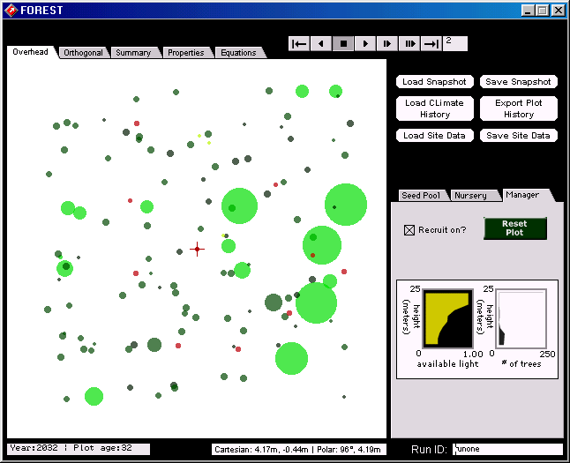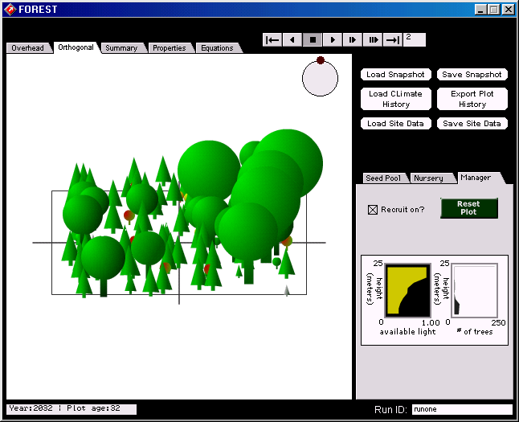
Overhead and Orthogonal Views.
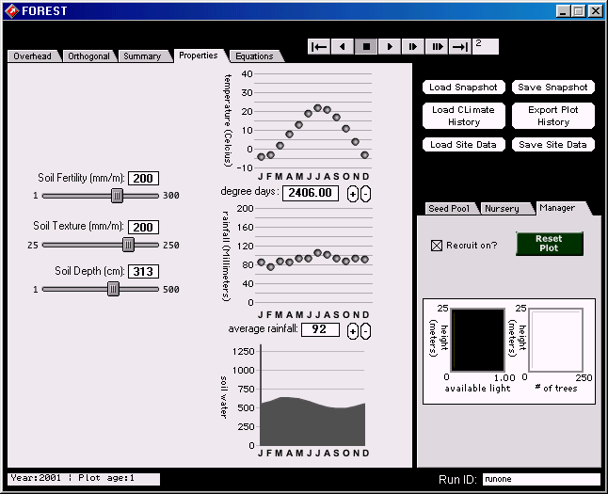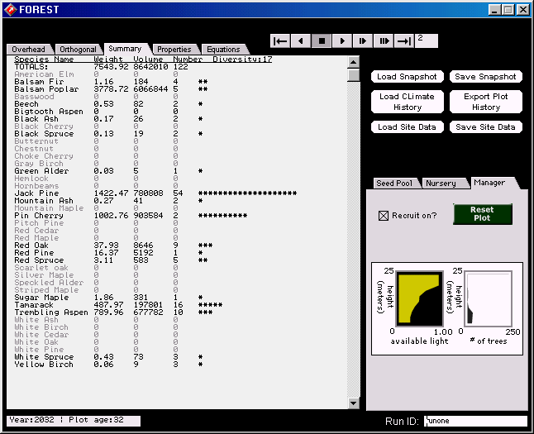
Properties Window and Summary Window

Features
The table below describes the interface features of Forest Simulator.

Run Pallet
The Run Pallet has the following buttons:
step back; rewind; stop; run; run at 1/2 speed; run at 1/4 speed; step.

Rewind plays backward, through the simulation you just ran. But if you run forward from there it runs the simulation starting with the state you see on the screen, and does not replay the old run that you just ran backwards (so rewind has limited usefulness).

The Step button advances the simulation a certain number of years, according to what you type in the box to the right of the button.

Overhead Scroll Over  Scrolling over a tree in overhead or orthogonal vew shows a pop up menu with information about that tree: Height (Hgt), Diameter (Dmr), Species, Age, Site Quality (SQ), Light Factor (LF), Growth Rate (dD) (See the section on Equations for a description of these). | 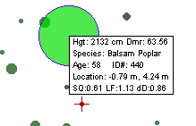
Tree Inspector  By clicking on a tree once in the overhead or orthogonal view, you will bring up the tree inspector. In the tree inspector you can  - Change the species, age, diameter, and location of the tree you clicked on.  - Remove the tree from the plot  Note: you can also remove a tree by putting your mouse over it and pressing the "D" key. | 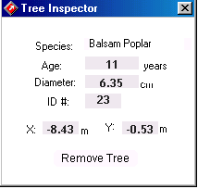

Seed Pool, Nursery, and Manager Tools  In the Manager you can  - Reset the plot (i.e. return to an empty plot). This feature does not reset any changes you have made to the seed pool or properties windows  - Turn recruitment on and off. When "Recruit On?” is checked, new trees can come on to the plot, when it is not checked, no new trees can seed in (but you can plant them by hand using the nursery tool.)  - View graphs of height vs. available light and number of trees.  In the Seed Pool you can  - View a list of species available.  - Remove a tree from the seed pool (prevent it from growing) by clicking on it. (To restore a species to the seed pool click on it again.) New trees will not germinate for trees deselected in the seed pool, but you can still plan any species by hand using the Nursery tool.  In the Nursery you can  - View a list of species available.  - Select a species to plant by clicking on it. Plant a tree by clicking on the plot in Overhead view. See the Tree Inspector above for how to set (or change) the diameter and age of the new tree.  - View the maximum height, maximum diameter, and growth rate for the species selected. This is from the fixed "species parameters" (see bleow) of the sepecies, it isnot a reflection or maeaurement of the current plot on the screen.  - Go to a Web page describing the species. | 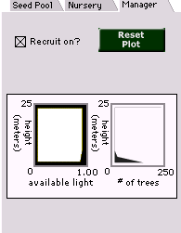
Temperature (Properties Window)  The temperature graph displays average monthly temperature in Celsius.  You can change the temperature by dragging each month’s temperature with the cursor, or by clicking on + and – buttons to move the whole profile up or down. The value that gets plugged into the growth equations can be found in the degree-days box.  365  Degree days = Σ (T_{d} – 7.2 º C)  d=1  Or, the sum of the daily temperature (T_{d}) minus 7.2 ºC (the temperature at which trees stop growing) as d (day) goes from 1 to 365 (1 year). | 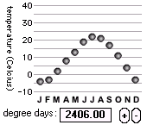
Rainfall (Properties Window)  The rainfall graph displays average monthly rainfall.  You can change this rainfall the same way you change the temperature, by dragging each month’s rainfall individually or clicking on the + and – buttons to raise or lower the whole profile.  The value that gets plugged into the growth equations is the average yearly rainfall, which can be found in the average rainfall box. | 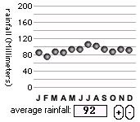
Soil Sliders (Properties Window)  All of the soil sliders can be changed by dragging the slider with the mouse.  Soil Fertility is a fertility index measured in units equivalent to  grams of nitrogen per hectare (10,000 m²)  Soil Texture, measured in mm water / m soil, tells how much water can be held by the soil. (e.g. how clayey or sandy the soil is.) A soil texture of 25 is sandy. A texture of 250 clayey.  Soil Depth measures the centimeters of soil above the bedrock. | 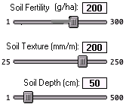
Growth Equations  You can look at the equations that run the model. They are not in particularly readable form (Director Lingo script). This is for advanced users. You can change the equations also--don't try this without adult supervision! See below for descriptions of the model. (the RESET button does not work--a bug) | 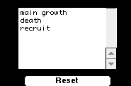

Files, Data Management, and Configuration

Configuration Files

There are several files you can edit to alter the configuration of the simulation.

defaultsnapshot.dat. When you launch SimForest it loads a file called defaultsnapshot.dat to determine the beginning arrangement of planted trees. To use this customization, run the simulation, create a site you want to re-use (either by planting trees or running), and do Save Snapshot. Save this file with some name, ex. pineForest1.dat. Make a copy of this file called "defaultsnapshot.dat" and put it in the main SimForest folder. To see it work, quit and re-launch.

defaultsitedata.dat. Similar to dafaultsnapshot.dat above, but for the site properties and seed pool. Use Save Site Data to create a site properties file, and make a copy called defaultsitedata.dat in the main SimForest folder.

treedata.dat. This file contains the species-specific data for all species. You can add or remove files from this file to limit or extend the available species. You can change the parameters, color, or shape of an existing species. You can invent new species! See below for the file format.

urlinfo.dat. This file contains two URLs used by the program. The first points to the SimForest Help File, and is where the user is taken when they click on the Help button. This can be customized to, for example, point to a page that gives the current class assignment.

The second URL is a file that contains information about all the species. When the user selects a species in the Nursery tool, then clicks the Go To URL button, it goes to a web site page location in this file. More specifically, the button click takes you to a URL <filename>#treename, for example, ddc.hampshire.edu/simforest/software/treedescriptions.html#maple. Where <filename> is the file name given in urlinfo.dat, and <treename> is the name of the species **with the spaces removed**. The tree info file should be constructed with HTML anchors for each species.

Here is a sample urlinfo.dat file (note that the URLS go on lines 2 and 4, lines 1 and 3 are comments):

#General help URL:
ddc.hampshire.edu/simforest/software/mainhelp.html
#Tree info URL:
ddc.hampshire.edu/simforest/software/treedescriptions.html

NOTE: Due to a Director bug, you can't include "http://" in URLS in the windows version of this file.

Saving and Loading Files

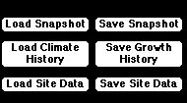

These buttons bring up a file dialog for you to specify a file name to load or save to. See below for the formats and contents of these files.

- Load Snapshot: Loads in a set of trees onto the site.
- Save Snapshot: Saves the current set of trees to be able to load in later.
- Load Climate History: Allows you use a file with monthly temp and rainfall values over many years. When you load a climate history this data is used to run the simulation rather than the rainfall and temperature settings in the Properties window.
- Save Growth History: Saves information in the Summary View to three files, showing, changes in the total number, volume, and weight for each species over all of the years in the run (since the last resetting of the plot). See below for more on the file structure. This cannot be opened again in SimForest, but it is to allow you to plot data using excel. This takes a LONG TIME to save if your run is many years long (we are working to fix this…).
- Load Site Data: Loads info into the properties window: temperature, rainfall, soil fertility, texture, and depth. Also loads the seed pool info (which species are turned on in the seed pool tool).
- Save Site Data: Saves info from the properties window: temperature, rainfall, soil fertility, texture, and depth. Also saves the seed pool info (which species are turned on in the seed pool tool).

File formats:
Most of the files that are saved or loaded are in tab delimited text format, allowing you to look at and edit them in a spread sheet program.

The Run ID: The Run ID entered in the lower right of the simulation is a way to identify a particular experimental run. The current RunID is saved as part of the data in the Snapshot and the Growth History files. You can type anything in the RunID text box to help you keep track of your experimental runs, for example "1st Run at 70 Degrees".
** NOTE; Currently there is a bug in the program such that you can not (should not!) type the letter "d" in the RunID box. This bug is related to the feature whereby you can put your mouse over a tree and press D to delete it.

Snapshot file. A tab delimited text file one line for each tree on the plot. Stores this information:
Run ID, Year, Tree ID, Species Name, Age, Diameter (cm), Height (cm), LocationX (M), LocationY (M).
For example: runone, 2003, 1, Basswood, 99, 51.54, 2660.46, -2.29, 4.99.
For a given saved file, the RunID and Year will all be the same.

Site Data file. A tab delimited text file storing the site properties and seed pool list . The file has lines describing the data that is in the line below it. Lines 1&2 are soil texture, depth, fertility. Line 3 is a key to lines 4 & 5. Line 4 has temp data for 12 months. Line 5 has rainfall data for 12 months. Line 6 is a list of the species in the seed pool. Below is an example.

Soil Texture Soil Depth Soil Fertility
250 5.00 300
Plot Age (Precipitation (mm) or Temperature (Celcius)) Jan Feb Mar Apr May Jun Jul Aug Sep Oct Nov Dec
2002 T_avg -4.00 -3.00 2.00 8.00 13.00 19.00 22.00 21.00 17.00 11.00 4.00 -3.00
2002 P_avg 86.00 76.00 88.00 86.00 94.00 94.00 106.00 102.00 94.00 88.00 94.00 92.00
Sugar Maple Beech Yellow Birch Black Birch White Ash
Mountain Maple Striped Maple Pin Cherry Choke Cherry

treedata.dat file. This file contains the species-specific data for all species. You can add or remove files from this file to limit or extend the available species. You can change the parameters, color, or shape of an existing species. You can invent new species! It is a tab delimited text file. The first row is a header row summarizing the types of info. Then there is one row for each species. There are 18 parameters for each species:

name, max age, max diameter, max height, b2, b3, g, c, light, nitrogen, DEGDmax, DEGDmin, DTmin, WLmax, maxSaplings, rgb1, rgb2, shape

(Note: we may also add a parameter called maxSaplings)

An example row (with commas instead of tabs):

Sugar Maple, 400, 170, 3350, 37.8, 0.111, 118.7, 1.57, 3, 2, 3500, 1111, 0.567, 0.35, 3, 00FF00, 006600, maple_shape

Most of these parameters are explained in the section explaining the Growth Model. Here we will describe the last three parameters: rgb1, rgb2, shape. Trees are drawn in 3-D (orthogonal) view with a color gradation between two colors. rgb1 and rgb2 are the RGB color values of these two colors, expressed in hex format. (To find the hex number for a color see one off these web sites: hotwired.lycos.com/webmonkey/reference/color_codes/, or dreamartists.com/hexcode.html.) The available Shape values are:

ash_shape, birch_shape, cedar_shape, cherry_shape, maple_shape, nut_shape, oak_shape, pine_shape, spruce_shape

Growth History files. Saves the data for each species (not each tree) for every year in the run. Basically it saves the data shown in the Summary view for an entire run. Three files are created, recording: the number of trees, the tree volumes, the tree weights. This allows you to plot (in Excel) any one of the three properties over years. The names of the three files are as in RUNxxN.dat, RUNxxV.dat, and RUNxxW.dat, where "RUNxx" defaults to the RunID name, but you can enter whatever you like (you are prompted after pushing the Save Growth History button. The file format is a tab delimited text file). There is one row for each year of the run. The first column is the year, the last is the total, and between these there is one column for each species. The first row is a header line with the names of all of the species. The rows are listed in REVERSE order of years (this is a bug!). Here is an example file (shown as a table) for the tree count file ("…N.dat") for a five year run with only four species rows.

Age | Sugar Maple | Beech | Yellow Birch | Red Cedar | total
5 | 9 | 11 | 0 | 0 | 45
4 | 8 | 11 | 0 | 0 | 43
3 | 8 | 10 | 0 | 0 | 39
2 | 7 | 10 | 1 | 0 | 38
1 | 7 | 10 | 1 | 0 | 39
0 | 7 | 10 | 1 | 0 | 39

To plot in Excel: Open the file into Excel. (On some computers may need to import a tab delimited file but on mine it opens OK automatically). Due to the bug of rows in reverse order, due the following to reverse the row order: sort, by Age column, having checked the "header column" button. Next select all columns but the first one ("age"), and click the chart wizard or do Insert Chart in the menu. I was easily able to follow instructions to create the following column-style chart. You can fancy it up with axis labels, etc.

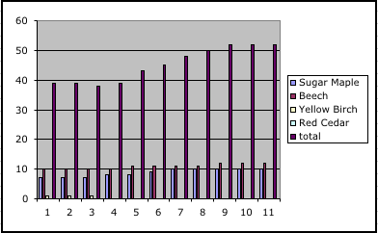

Climate History file:
Climate history is a tab delimited text file with temperature and rain fall data for a series of years, with averages for each of the 12 months of the year. Rows alternate between rainfall (precipitation) and temperature. Below is a sample file, shown in table format.

1951 | T_avg | 10 | 11 | 14 | 20 | 25 | 30 | 32 | 31 | 28 | 23 | 24 | 10
1951 | P_avg | 20 | 40 | 40 | 80 | 40 | 60 | 120 | 90 | 60 | 40 | 60 | 40
1952 | T_avg | 10 | 10 | 15 | 20 | 22 | 30 | 32 | 34 | 25 | 20 | 15 | 11
1952 | P_avg | 40 | 40 | 40 | 60 | 70 | 120 | 40 | 60 | 40 | 60 | 20 | 120
1953 | T_avg | 10 | 10 | 15 | 20 | 25 | 30 | 25 | 24 | 21 | 23 | 20 | 17
1953 | P_avg | 40 | 25 | 80 | 60 | 90 | 30 | 35 | 65 | 60 | 70 | 50 | 60

The Tree Growth Model

Virtually all forest growth simulation programs are in some way derivatives of the pioneering work by Botkin, Janak, and Wallis in 1972(a,b), initially called JABOWA (Dale and Shugart, 1985), which is based on the "gap phase" model of forest growth (our work is related to the more recent improved program, JABOWA II; Botkin and Nesbit & 1992; Botkin, 1993). Gap Phase models a small area (plot) of a forest (about 20 meters on a side), with the assumption that all of the trees on the plot affect all of the other trees on the plot by proximity. Tree location is not even taken into account. A tree is assumed to provide a certain amount of shade for all of the trees on the plot (which is reasonable if you consider how the shadow moves during the day). The model does not deal with the effect of the plots (or trees) surrounding a plot; it is a local model. Assuming you start with an empty plot, seeds available from the seed pool are assumed to germinate for species where the conditions are right. The model ignores the saplings until they are "breast height" (137 cm) and introduces them into the plot at this height. Then they grow and compete with each other for light. (The model does not model how trees compete for the nutrient pool -- partly because decomposing leaves and wood add to the nutrient pool). Usually a couple of large trees will dominate the plot and others will stagnate or die. When the large trees die they open up a "gap" (thus "gap phase"), where light can pour in and new seeedlins will germinate.

Forest growth models continue to be an area of active scientific research, and many forest growth simulators exist (including FORET (Shugart and West, 1977), FORSKA (Prentice & Leemans 1990; Prentice et al. 1993), ZELIG (Urban, 1990; Urban et al 1991; Urban and Shugart, 1992), SIMA (Kellomäki et al, 1992, 1994; Kellomäki, 1995), SORTIE (Pacala, 1993)). These simulation models have various differences, such as the number of tree species allowed, additional environmental constraints and chemical conditions. But all are similar in that they are based on the common gap model structure (Shugart 1984). Significantly, they are geared more to professional forestry and graduate level study, and are not intended as educational tools. Our Forest Simulator software has a relatively simple forest growth model, but its interface and architecture are geared at teaching botany and ecology principles and scientific inquiry skills. Each of these programs has similar drawbacks for undergraduate research and classroom learning.

Some Simplifications in the Model

Location: A tree’s location on the plot does not matter, only its height, diameter, age, and "leaf wight" enter into the equations. In the simulation, every tree shades or is shaded by every other tree equally regardless of their proximity to each other.

Trees and the Environment: In this model the environment (climate, light, and soil) determine tree growth. Tree growth determines available light but has no impact on climate, water, or nutrients (i.e. roots do not increase the soil’s ability to hold water, and nutrients are not lost when trees are cut.)

Main Growth Equation

dD = G * D * (( Dmax – D)/Dmax )* Lf * Tf * Wf * Sf

dD = change in diameter over time
G = optimal growth rate
D = diameter
Dmax = the maximum diameter (specific to each
species and based on field observations.)
Lf = light factor*
Tf = temperature factor**
Wf = water factor**
Sf = soil nutrient factor**

(G and Dmax are specific to each species, D is specific to the tree, and the other variables are determined through sub-equations.)

*Values range between 0 and 1. 45 where 0 = least favorable and 1.45 = the most favorable. Calculation based on available light and species properties.

**Values range between 0 and 1, where 0= least favorable conditions, and 1= most favorable. Calculation based on site properties and species properties.

In this equation, the increment of growth is proportional to the diameter of the tree, the growth rate, the closeness of the diameter to the maximum diameter, and the suitability of the site for that tree. This means that when at tree is significantly smaller than its maximum diameter, its growth rate increases with an increase in diameter, but as the trunk nears its maximum size the rate of growth decreases. Also, the more the suitable the site is for the tree (i.e. the closer the, water, temperature and soil nutrient factors are to 1, and the light factor to 1.5) the greater the yearly growth rate.

When you mouse-over a tree the following information shows up in the pop-up:

Site Quality (SQ) – A number between 0 and 1 that quantifies the
suitability (in terms of soil nutrients, water, and temperature) of a site
for that species of tree. The higher the number the more suitable the
conditions. SQ = Tf * Wf * Sf.
Light Factor (LF) – A number between 0 and 1.45. It is calculated from
the shading leaf weight (number and type of trees growing above the
tree in question), and the light response of the species (shade tolerant,
intolerant, or intermediate) The larger the number the more suitable
the light conditions are for the scrolled tree.
Growth Rate (dD) - How much the tree grew this year.

Tree Growth Parameters

Each species has a number of parameters that characterize it. As mentioned above, these properties are stored in the treedata.dat file (which you can edit). All of these parameters (like the equations) are based on limited empirical evidence, theoretical assumptions, approximations, and simplifications, as used by Botkin's gap phase model (except in cases where we tweaked things for better results).

- maxage - The oldest possible age for the species, after which is should be dead.
- maxdiameter - Similar to maxage.
- maxheight - Similar to maxage.
- b2 and b3 - Fitting parameters for the shape equation. The height of the tree is a quadratic function based on the diameter, with b2 being the linear term and b3 the quadratic term.
- g - The max growth rate for the species.
- c - leaf density - Describes the relation between tree diameter and "shading leaf weight" (the amount of light the tree blocks).
- light response - Tree's tolerance to light/shade. Has three possible values: 1=shade intolerant; 2 = intermediate; 3 = shade tolerant.
- nitrogen factor - Relationship between tree growth and site fertility. Has three possible values: 1=nitrogen intolerant; 2 = intermediate; 3 = nitrogen tolerant.
- DEGDmax - The maximum degree day value that allows for growth.
- DEGDmin - The minimum degree day value that allows for growth.
- DTmin - Describes tolerance to flooding (low value means more flood tolerance). It is the minimum distance to the water table to allow growth.
- WLmax - The tolerance for draught. A higher number means more draught tolerant.
- maxSaplings - The maximum number of saplings that can enter for that species in a year (the actual recruitment is some percentage of this, based on several factors).
- (assume min growth rate is .01 cm per year for all species)

(Note: we may also add a parameter called maxSaplings)

Explanation of other Equations

(To be completed.) See the Appendix for an equation listing.

Three calculations, degree days, available water, and available light, are a bit more arcane and are not described in detail in this document (nor are they available for inspection in either the black box or glass box forest simulators). All of the equations and parameters that the main model deals with iterate once per year. The water and degree day equations iterate over each of the 12 months, and the light equation must iterate over each tree on the plot to determine how much light it available at all possible heights from ground to canopy top. The equations that determine the available water (water table, annual water balance, water stress, and flood factor) are too complex and not relevant to botany, and are not shown. They combine rainfall, soil type, and temperature, and include calculations for snow pack, snow melt evapo-transportation, etc. The other

Some miscellaneous notes: The number 137 appears from 137 cm being where diameter is measured at "breast height." Volume is assumed to be proportional to height * diameter. Degree days = Sum[over all 365 days] (Temp – 7.2), in degrees Celsius. (Note: 7.2 is approximately (the temperature at which trees stop growing.). Lf == light factor, usu. max 1. dd == delta diam (growth rate); site quality has max of 1.

Equations in the Simulation

Every year the simulation does the following: 1) runs the Main Growth Equation over each tree to determine how much each tree will grow; 2) runs the Death equation over each tree to determine which trees will die; 3) runs the Recruitment Equation over each species in the seed pool to determine what new trees will be created (they are created as saplings 137 cm feet tall).

Below are the equations as they appear in Director Lingo script:

Main growth equation
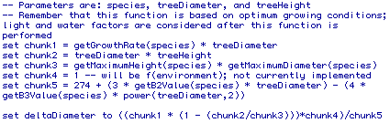

Death Equation
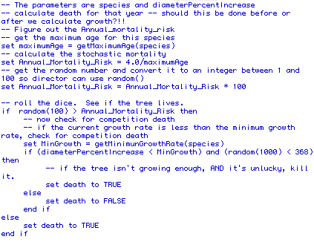

Recruitment Equation
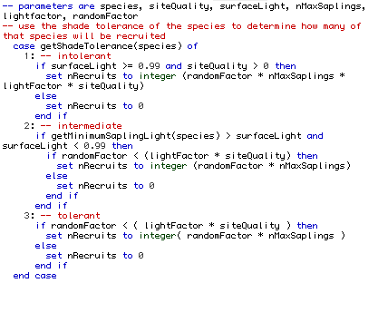

Appendices

File "treedata.dat ORIG" contents

The contents of treedata.dat ORIG, with parameters for the species we originally provided are as follows:

#name | max age | max diameter | max height | b2 | b3 | g | c | light | nitrogen | DEGDmax | DEGDmin | DTmin | WLmax | maxSaplings | rgb1 | rgb2 | shape
Sugar Maple | 400 | 170 | 3350 | 37.8 | 0.111 | 118.7 | 1.57 | 3 | 2 | 3500 | 1111 | 0.567 | 0.35 | 3 | 00FF00 | 006600 | maple_shape
Beech | 366 | 160 | 3660 | 44 | 0.137 | 87.7 | 2.2 | 3 | 2 | 3333 | 1167 | 0.489 | 0.35 | 3 | 00FF00 | 006600 | maple_shape
Yellow Birch | 300 | 100 | 3050 | 58.3 | 0.291 | 143.6 | 0.486 | 2 | 2 | 2944 | 1111 | 0.6 | 0.245 | 15 | ffff63 | 006600 | birch_shape
Black Birch | 300 | 100 | 3050 | 58.3 | 0.291 | 143.6 | 0.486 | 2 | 2 | 2944 | 1111 | 0.6 | 0.245 | 15 | 424242 | 006600 | birch_shape
White Ash | 150 | 150 | 2440 | 30.7 | 0.102 | 147.5 | 1.75 | 2 | 1 | 6082 | 1341 | 0.4 | 0.245 | 10 | cec6ce | 006600 | ash_shape
Mountain Maple | 25 | 14 | 500 | 53.8 | 2 | 72.6 | 1.13 | 3 | 2 | 3500 | 1000 | 0.489 | 0.274 | 2 | 00FF00 | 006600 | maple_shape
Striped Maple | 30 | 23 | 1000 | 76.7 | 1.7 | 109.8 | 1.75 | 3 | 2 | 3500 | 1111 | 0.567 | 0.274 | 2 | 00FF00 | 006600 | maple_shape
Pin Cherry | 30 | 28 | 1126 | 70.6 | 1.26 | 227.2 | 2.45 | 1 | 1 | 3333 | 611 | 0.567 | 0.378 | 60 | 00FF00 | 006600 | cherry_shape
Choke Cherry | 20 | 10 | 500 | 72.6 | 3.63 | 233.3 | 2.45 | 1 | 2 | 5556 | 944 | 0.567 | 0.378 | 60 | 00FF00 | 006600 | cherry_shape
Balsam Fir | 200 | 86 | 2290 | 50.1 | 0.291 | 102.7 | 2.5 | 3 | 3 | 2056 | 389 | 0.211 | 0.245 | 2 | 00FF00 | 006600 | cedar_shape
Red Spruce | 400 | 60 | 2290 | 71.8 | 0.598 | 50.7 | 2.5 | 3 | 3 | 2111 | 722 | 0.489 | 0.245 | 2 | 00FF00 | 006600 | spruce_shape
White Birch | 140 | 76 | 3050 | 76.6 | 0.504 | 190.1 | 0.486 | 2 | 3 | 2222 | 389 | 0.544 | 0.378 | 10 | cec6ce | 006600 | birch_shape
Mountain Ash | 30 | 10 | 500 | 72.6 | 3.63 | 155.6 | 1.75 | 2 | 2 | 2222 | 1000 | 0.544 | 0.29 | 2 | 00FF00 | 006600 | ash_shape
Red Maple | 150 | 150 | 3660 | 47 | 0.156 | 213.8 | 1.75 | 2 | 3 | 6889 | 1111 | 0.322 | 0.45 | 3 | c61829 | 006600 | maple_shape
Scarlet Oak | 200 | 30 | 3050 | 194.2 | 3.23 | 128.7 | 1.75 | 1 | 3 | 4444 | 2167 | 0.933 | 0.45 | 3 | b51010 | 006600 | oak_shape
Hornbeam | 150 | 30 | 1520 | 92.2 | 1.53 | 144.4 | 0.486 | 1 | 2 | 5722 | 1528 | 0.933 | 0.45 | 3 | 00FF00 | 006600 | maple_shape
Hop Hornbeam | 150 | 30 | 1520 | 92.2 | 1.53 | 144.4 | 0.486 | 1 | 2 | 5722 | 1528 | 0.933 | 0.45 | 3 | 00FF00 | 006600 | maple_shape
Green Alder | 30 | 5 | 300 | 65.2 | 6.52 | 143.3 | 2 | 2 | 3 | 1667 | 300 | 0.322 | 0.13 | 10 | 00FF00 | 006600 | oak_shape
Speckled Alder | 30 | 8 | 400 | 65.8 | 4.1 | 196.9 | 2 | 2 | 3 | 2944 | 1208 | 0.211 | 0.05 | 10 | 00FF00 | 006600 | oak_shape
Chestnut | 200 | 122 | 2740 | 42.7 | 0.175 | 195.2 | 1.75 | 2 | 3 | 4722 | 2048 | 0.933 | 0.45 | 0 | 00FF00 | 006600 | nut_shape
Black Ash | 70 | 60 | 2130 | 66.4 | 0.554 | 96.2 | 1.75 | 2 | 1 | 2944 | 944 | 0.322 | 0.13 | 3 | 424242 | 006600 | ash_shape
Butternut | 90 | 91 | 3050 | 64 | 0.352 | 192.2 | 1.75 | 1 | 2 | 3611 | 1778 | 0.933 | 0.45 | 3 | 00FF00 | 006600 | nut_shape
White Spruce | 200 | 53 | 3350 | 121.2 | 1.14 | 91.8 | 2.5 | 2 | 1 | 2083 | 333 | 0.544 | 0.245 | 2 | cec6ce | 006600 | spruce_shape
Black Spruce | 250 | 46 | 2740 | 113.9 | 1.24 | 32 | 2.5 | 2 | 3 | 2111 | 333 | 0.156 | 0.13 | 2 | 424242 | 006600 | spruce_shape
Jack Pine | 185 | 50 | 3050 | 116.5 | 1.16 | 142 | 2 | 1 | 3 | 2222 | 639 | 1.25 | 0.53 | 50 | 00FF00 | 006600 | pine_shape
Red Pine | 275 | 91 | 3050 | 64 | 0.352 | 156.4 | 2 | 1 | 3 | 2278 | 1111 | 1.25 | 0.5 | 3 | d60808 | 006600 | pine_shape
White Pine | 450 | 101 | 4570 | 87.8 | 0.435 | 141.2 | 2 | 2 | 3 | 3333 | 1167 | 1 | 0.45 | 4 | cec6ce | 006600 | pine_shape
Trembling Aspen | 100 | 100 | 3050 | 58.3 | 0.291 | 173.7 | 0.486 | 1 | 2 | 3111 | 333 | 0.7 | 0.45 | 10 | 00FF00 | 006600 | cherry_shape
White Oak | 600 | 122 | 3050 | 47.8 | 0.198 | 72 | 1.75 | 2 | 2 | 5669 | 1648 | 0.933 | 0.45 | 10 | cec6ce | 006600 | oak_shape
Red Oak | 400 | 100 | 3050 | 58.3 | 0.291 | 107.7 | 1.75 | 1 | 3 | 2278 | 1111 | 1.25 | 0.5 | 10 | d60808 | 006600 | oak_shape
White Cedar | 400 | 100 | 2440 | 46 | 0.23 | 35.7 | 2.5 | 2 | 1 | 2056 | 833 | 0.1 | 0.05 | 2 | cec6ce | 006600 | cedar_shape
Hemlock | 600 | 150 | 3660 | 47 | 0.156 | 86 | 2 | 3 | 3 | 3644 | 1342 | 0.489 | 0.245 | 3 | 00FF00 | 006600 | cedar_shape
Silver Maple | 125 | 122 | 3960 | 62.7 | 0.257 | 164.8 | 1.57 | 2 | 1 | 5000 | 1222 | 0.4 | 0.187 | 2 | 848484 | 006600 | maple_shape
Tamarack | 200 | 85 | 3050 | 68.5 | 0.403 | 86.3 | 2 | 1 | 2 | 2111 | 333 | 0.156 | 0.05 | 10 | 00FF00 | 006600 | spruce_shape
Pitch Pine | 200 | 91 | 3050 | 64 | 0.325 | 86.5 | 2 | 1 | 3 | 3222 | 2111 | 1.25 | 0.53 | 2 | 00FF00 | 006600 | pine_shape
Gray Birch | 50 | 38 | 910 | 40.7 | 0.535 | 119.5 | 0.486 | 1 | 3 | 2667 | 1556 | 1 | 0.45 | 10 | 9c9c9c | 006600 | birch_shape
American Elm | 300 | 152 | 3840 | 48.7 | 0.16 | 180 | 1.6 | 2 | 1 | 6667 | 1056 | 0.4 | 0.245 | 3 | 00FF00 | 006600 | oak_shape
Basswood | 140 | 137 | 4270 | 60.3 | 0.22 | 169.8 | 1.6 | 3 | 1 | 3333 | 1278 | 0.567 | 0.29 | 3 | 00FF00 | 006600 | cherry_shape
Bigtooth Aspen | 70 | 60 | 2130 | 66.4 | 0.554 | 176.7 | 0.486 | 1 | 2 | 3333 | 1167 | 0.4 | 0.187 | 3 | 00FF00 | 006600 | cherry_shape
Balsam Poplar | 150 | 100 | 2440 | 46 | 0.23 | 232.5 | 0.486 | 1 | 1 | 2389 | 556 | 0.4 | 0.378 | 3 | 00FF00 | 006600 | birch_shape
Black Cherry | 258 | 91 | 3050 | 64 | 0.352 | 166.7 | 2.45 | 2 | 2 | 6081 | 2166 | 0.567 | 0.378 | 10 | 424242 | 006600 | cherry_shape
Red Cedar | 250 | 60 | 1520 | 46.1 | 0.384 | 88.7 | 2 | 1 | 3 | 5669 | 1648 | 0.7 | 0.45 | 3 | c61829 | 006600 | cedar_shape

Equation Descriptions, Draft

These are from the glass box project (and will differ in form, but not content, from the black box equations shown in Lingo script above.)

-----
Light Factor Computation (shade-tolerant)
Description: The actual computation of the light factor for shade-tolerant species.
Needed for: Light Factor computation
Symbol: light factor (tolerant)
Units: ???
(1.0 * (1.0 - (2.718281828459045 ^ (-4.64 * (avail light - 0.05)))))
-----
Light Factor Computation (shade-intolerant)
Description: The actual computation of the light factor for shade-intolerant species.
Needed for: Light Factor computation
Symbol: light factor (intolerant)
Units: ???
(2.24 * (1.0 - (2.718281828459045 ^ (-1.136 * (avail light - 0.08)))))
-----
Light Factor
Description: The light factor for the current species and height
Needed for: Recruitment and growth
Symbol: light factor
Units: Scalar [0-1]
max(( CASE: IF (3.0 = light(Species Table)) RETURN light factor (tolerant) ELSE RETURN light factor (intolerant) ), 0.0)
-----
Nitrogen Factor Computation (nitrogen-intolerant)
Description: The actual computation of the nitrogen factor for nitrogen-intolerant species.
Needed for: Nitrogen Factor computation
Symbol: nitrogen factor (intolerant)
Units: ???
((-0.6 + (1.0 * (2.79 * (1.0 - (10.0 ^ (-1.0 * 0.00179 * (soilFertility(Site Table) + 219.77))))))) / 2.19)
-----
Nitrogen Factor Computation (nitrogen-intermediate)
Description: The actual computation of the nitrogen factor for intermediate nitrogen-tolerance species.
Needed for: Nitrogen Factor computation
Symbol: nitrogen factor (intermediate)
Units: ???
((-1.2 + (1.3 * (2.94 * (1.0 - (10.0 ^ (-1.0 * 0.00234 * (soilFertility(Site Table) + 117.52))))))) / 2.622)
-----
Nitrogen Factor Computation (nitrogen-tolerant)
Description: The actual computation of the nitrogen factor for nitrogen-tolerant species.
Needed for: Nitrogen Factor computation
Symbol: nitrogen factor (tolerant)
Units: ???
((-5.0 + (2.9 * (2.99 * (1.0 - (10.0 ^ (-1.0 * 0.00175 * (soilFertility(Site Table) + 207.43))))))) / 3.671)
-----
Nitrogen Factor
Description: The nitrogen factor for the current species and site
Needed for: Recruitment and growth
Symbol: nitrogen factor
Units: Scalar [0-1]
( CASE: IF (1.0 = nitrogen(Species Table)) RETURN nitrogen factor (intolerant) IF (2.0 = nitrogen(Species Table)) RETURN nitrogen factor (intermediate) ELSE RETURN nitrogen factor (tolerant) )
-----
Wilt Factor
Description: The wilt factor equation for the current species
Needed for: Recruitment and growth
Symbol: wilt factor
Units: Scalar [0-1]
max(0.0, (1.0 - ((water stress / wlMax(Species Table)) ^ 2.0)))
-----
Temperature Factor
Description: The temperature factor equation for the current species
Needed for: Recruitment and growth
Symbol: temperature factor
Units: Scalar [0-1]
max(0.0, ((4.0 * (degree days - degDaysMin(Species Table)) * (degDaysMax(Species Table) - degree days)) / ((degDaysMax(Species Table) - degDaysMin(Species Table)) ^ 2.0)))
-----
Site Quality
Description: The site quality equation
Needed for: Recruitment and growth
Symbol: site quality
Units: Scalar [0-1]
(temperature factor * nitrogen factor * wilt factor)
-----
Recruitment (shade-intolerant)
Description: The recruitment equation for shade-intolerant species.
Needed for: Simulation
Symbol: recruitment (intolerant)
Units: Trees
( CASE: IF ((avail light > 0.989999) & (site quality > 0.0)) RETURN (rand(1.0) * maxSaplings(Species Table) * light factor * site quality) ELSE RETURN 0.0 )
-----
Recruitment (shade-intermediate)
Description: The recruitment equation for shade-intermediate species.
Needed for: Simulation
Symbol: recruitment (intermediate)
Units: Trees
( CASE: IF ((minSaplingLight(Species Table) > avail light) & (avail light < 0.99)) RETURN (rand(1.0) * maxSaplings(Species Table)) ELSE RETURN 0.0 )
-----
Recruitment (shade-tolerant)
Description: The recruitment equation for shade-tolerant species.
Needed for: Simulation
Symbol: recruitment (tolerant)
Units: Trees
( CASE: IF (rand(1.0) < (light factor * site quality)) RETURN (rand(1.0) * maxSaplings(Species Table)) ELSE RETURN 0.0 )
-----
Recruitment
Description: The recruitment number equation: gives the number of new saplings of a species
Needed for: Simulation
Symbol: recruitment
Units: Trees
( CASE: IF (1.0 = light(Species Table)) RETURN recruitment (intolerant) IF (2.0 = light(Species Table)) RETURN recruitment (intermediate) ELSE RETURN recruitment (tolerant) )
-----
Recruitment Size
Description: The recruitment size equation: gives the size of newly recruited saplings.
Needed for: Simulation
Symbol: recruitment size
Units: Centimeters
0.1
-----
Limiting Factors
Description: The limiting factors to growth: Returns the proportion of its maximum potential growth by which a tree will grow.
Needed for: Growth
Symbol: limiting factors
Units: Scalar [0-1]
(light factor * site quality)
-----
Maximum Potential Growth
Description: The maximum potential growth equation: Returns the increase in a tree's diameter under ideal conditions.
Needed for: Growth
Symbol: max. pot. growth
Units: Centimeters
((g(Species Table) * diameter(Tree Table) * (1.0 - ((diameter(Tree Table) * height(Tree Table)) / (maxDiameter(Species Table) * maxHeight(Species Table))))) / (274.0 + (3.0 * b2(Species Table) * diameter(Tree Table)) + (-4.0 * b3(Species Table) * (diameter(Tree Table) ^ 2.0))))
-----
Growth
Description: The growth equation: returns the amount to increase a tree's diameter in one year.
Needed for: Simulation
Symbol: growth
Units: Centimeters
(limiting factors * max. pot. growth)
-----
Stochastic Death Test
Description: The stochastic death test: Returns true if a tree should die due to simple aging.
Needed for: Death
Symbol: stochastic test
Units: Boolean
(rand(1.0) < (4.0 / maximumAge(Species Table)))
-----
Competition Death Test
Description: The competition death test: Returns true if a tree should die due to stalled growth.
Needed for: Death
Symbol: competition test
Units: Boolean
((growth < minGrowthRate(Species Table)) & (rand(1.0) < 0.3))
-----
Death
Description: The death equation: returns true if a tree should die.
Needed for: Simulation
Symbol: death
Units: None
( CASE: IF stochastic test RETURN true IF competition test RETURN true ELSE RETURN false )
-----
Diameter
Description: The diameter equation: Returns a tree's new diameter after growth.
Needed for: Simulation
Symbol: diameter
Units: Centimeters
(diameter(Tree Table) + growth)
-----
Height
Description: The height equation: Returns a tree's height based on its species and new diameter.
Needed for: Simulation
Symbol: height
Units: Centimeters
((b3(Species Table) * (diameter ^ 2.0)) + (b2(Species Table) * diameter) + 137.0)
-----
Life
Description: The life equation: Returns true if a tree lives through the year, or false if it dies this year.
Needed for: Simulation
Symbol: life
Units: Boolean
(isAlive(Tree Table) & !death)
-----
Age
Description: The age equation: Increments a tree's diameter every year.
Needed for: Simulation
Symbol: Age
Units: Years
(age(Tree Table) + 1.0)

Forestry and Ecology References:

Botkin, D.B. (1993). Forest Dynamics. Oxford Univ. Press: Oxford.
Botkin, D.B., J.F. Janak, and JR. Wallis. 1972.Some ecological consequences of a computer model of forest growth. J. Ecol., 60: 849-872
Botkin, D.B., J.F. Janak, and JR. Wallis. 1972.Rationale, limitations and assumtions of a Northeastern Forest Growth Simulator. IBM J. Research Development 16: 101-116
Botkin, D. B. and R. A. Nisbet. 1992 Forest response to climatic change: effects of parameter estimation and choice of weather patterns on the reliability of projections. Climatic Change 20:80-111
Dale, V.H, Doyle, T.W. and Shugart, H.H., (1985). A comparison of tree growth models. Ecological Modelling, 29: 145-169.
Kellomäki, S., Väisänen, H., Hänninen, H., Kolström, T., Lauhanen, R., Mattila, U. and Pajari, B. 1992. Sima: A model for forest succession based on the carbon and nitrogen cycles with application to silvicultural management of the forest ecosystem. Silva Carelica 22. 85.p. University of Joensuu, Faculty of Forestry. ISBN 951-708-060-3. ISSN 0780-822232. UDK 630.182.2, 630.2, 574.4. Gummerus Kirjapaino Oy, Jyväskylä 1992.
Kellomäki, S. 1995. Computations on the influence of changing climate on the soil moisture and productivity in Scots pine stands in Southern and Northern Finland. Climatic Change 29: 35-51.
Kellomäki, S. and Kolström, M. 1994. The influence of climatic change on the productivity of Scots pine, Norway Spruce, Pendula birch and Pubescent birch in southern and northern Finland. 1993. Forest Ecology and Management 65 (1994) 201-217.
Kellomäki, S. and Kolström, M. 1992. Simulation of tree species composition and organic matter accumulation in Finnish boreal forests under changing climatic conditions. Vegetatio 102: 47-68.
Kellomäki, S., Väisänen, H., Hänninen, H., Kolström, T., Lauhanen, R., Mattila, U. and Pajari, B. 1992. A simulation model for the succession of boreal forest ecosystem.. Silva Fennica 26: 1-18.
Mills, A. V. (1993).Predicting forest growth and composition - a test of the JABOWA modelusing data from Earl Stephens' study in the Tom Swamp tract.
Senior Thesis, Hampshire College, Amherst, MA.
Pacala, S.W., Canham, C.D., and Silander, J.A., JR. (1993).Forest models defined by field measurements: 1. The design of a northeastern forest simulator. Can. J. For. Res. 23: 1980-1988.
Shugart, H.H. (1984). A Theory of Forest Dynamics. Springer Verlag, NY.
Shugart, Jr. H. H. and D. C. West. 1977. Development of an Appalachian deciduous forest succession model and its application to assessment of the impact of Chestnut Blight. Journal of Environmental management 5:161-179
Urban, D.L., 1990. A versatile model to simulate forest pattern: a user's guide to ZELIGversion 1.0. Department of environmental sciences, University of Viginia, Charlottesville,VA, 108 pp.
Urban, D.L., G.B. Bonan, T.M. Smith, H.H. Shugart, 1991. Spatial applications of gap models. For. Ecol. Manage., 42, 95-110.
Urban, D.L., H.H. Shugart, 1992. Individual based models of forest succession. In D.C. Glenn-Lewin,R.K. Peet, T.T. Veblen (eds.): Plant Succession: Theory and Prediction.Chapman and Hall, London, pp. 249-286.

