SimForest-G User’s Guide

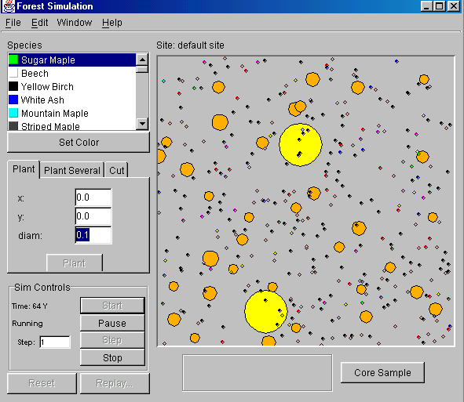

July 11, 2001

1.0 The Main Screen

Core Sampler
Species Key
Planting and Cutting
Sim Controls
Overhead View

Figure 1: The Main Screen

Features of the Main Screen

  - Species Key

The Species Key displays the species in the seed pool beside the colors with which they are displayed in the overhead view and graphs. To view all species use the scroll bars. To alter the color of a species,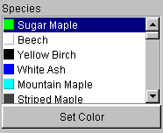select a species by clicking on it in order to highlight it and then press the set color button. This will bring up a color pallet from which you can select the color you want by clicking on it. To make the selected color the new species color press “OK”, to return to the default species color press “Reset.”

The species key is also where you can select species to plant, cut,
Figure 1.1: The Species Key graph etc. To select one species click on it. It will become
highlighted. To select a block of species hold down the shift key (on a pc) as you scroll down the list. To select several species that are not beside each other in the list hold down the control key (on a pc) as you click on the species you want.

  - Planting and Cutting
When the simulation is paused, the planting and cutting tools allow you to plant and cut trees.
1.21 Plant

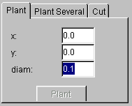
With the planting tool you can plant one tree each of one or more species, which are selected (highlighted in the species key) in the species key.
You can specify the location in terms of x and y coordinates as well as the diameter (in cm) of the sapling.
Once you have selected the species, location, and diameter, you can plant the tree(s) by pressing the “Plant Button.”
Plant Button

Figure 1.21: Plant

Plant Several

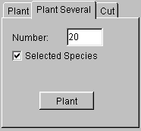 With the plant several tool, you are able to plant several trees. You can specify the number of trees to be planted. If the selected species box is checked, the specified number of trees will be planted for each selected species. In other words if 3 species are selected, 3 times the specified number of trees will be planted. If the selected species box is not checked, the simulation will plant the specified number of trees by planting a random combination of species from the species key. This tool does not allow you to specify the size or location of the trees planted. Once you have specified the number of trees (and selected the species if the selected species box is checked) you can plant these trees by pressing the “Plant Button”
Plant Button

Figure 1.22 Plant Several

  - Cut

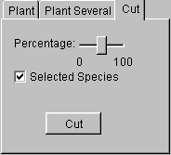With the cutting tool you can specify a certain percentage of trees to cut. If the selected species box is checked, pressing the “Cut Button” with cut that percentage of the selected species. If the selected species box is not checked, pressing the “Cut Button” will remove that percentage of the trees, by removing a random sample of the trees from the plot.

Cut Button

Figure 1.23 Cut
  - Sim Controls

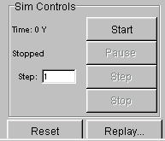The Start button allows you to begin a run. When the start button is pressed, trees will begin to grow.

The Pause button allows you to temporarily stop the simulation.
After this button is pressed, it becomes the Resume button.

The Resume button allows you to resume a paused run.

The Step button allows you to step the simulation a specified number of years. When the step button is pressed the simulation will run the specified number of years and then pause automatically. The step Figure 1.3 The Sim Controls button only works when the simulation is paused.

The Stop button stops the run. This differs from pausing the run because to restart the run you must press play at which point the current run record will be erased.

When the run is stopped you can also
- press the reset button which will remove all trees from the plot and return to year zero
- and press the replay button to watch the previous run again.

  - The Core Sampler

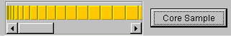The core sampler allows you to see a crossection of a tree trunk. To take a core sample, click on a tree in overhead view. This will turn its outline red. Then Figure 1.4: the Core Sampler click on the core sample button.
By scrolling over the core sample you can get a reading of the number (from the center) and size (in cm) or each ring

  - The Overhead View

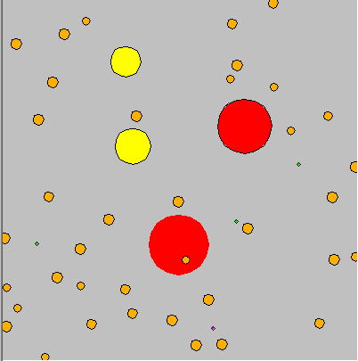 The overhead view gives you an image of the trees from above. They are colored according to the species key.

Figure 1.5: The Overhead View

