Writing an Inquiry-Based Curriculum for Forest Ecology that Uses a Computer Simulation of Forest Growth as a Tool for Learning

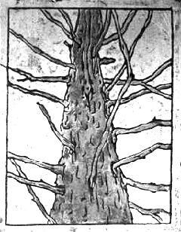

A Division III by Esther Anderson Shartar

Chair: Larry Winship

NS

May, 2001
Acknowledgements

This material is based on work supported by the National Science Foundation under the Grant No. DUE-9972486. Any opinions, findings, conclusions or recommendations expressed in this material are those of the author and do not necessarily reflect the views of NSF. I would like to thank my Div III committee: Larry Winship, Tom Murray, and Merle Bruno for their support, suggestions, and editing help; the SimForest Team: Tom Murray, Larry Winship, Ryan Moore, Roger Berlin, Matt Cornell, Jesse Doan, Neil Stillings, Steve Lester, and Peter Shaughnessy; the participants in the preliminary trials, the students in the Ecology of Old Growth Forests course, and the students in the Integrative Seminar of Environmental and Health Education (Ayala for being part of all three groups); the Andersons and the Shartars; my friends and family on and from Calef Hill, especially the folks at 447: Mom and Dad for being such an enthusiastic fan club, Elin for IM and late night phone calls, Laura and Carissa for flying kites when it really mattered, Adrienne for encouraging words over the phone, Joel for technical support (thanks for the splitter.); Nate for the beautiful illustrations and for driving down (6 hours round trip) most weekends to remind me how to take a study break; Meegan, Meghan, Becca, and Bill for being some of my first friends at Hampshire and best friends ever; Jon Shartar for his calm presence in times of crisis; the women of 54; the Hampshire College Farm Center, especially School to Farm; Spontaneous Combustion; and everyone else who has made my experience at Hampshire what it is.

Cover Illustration by Nathan Howe

Table of Contents

Chapter One: Scientific Inquiry, Computers, and SimForest . . . . 1
Introduction . . . . 1

Scientific Inquiry. . . . 2
What is it?. . . . 2
The Role of Inquiry in Science Education . . . . 3
Computers and Inquiry. . . . 5
The SimForest Program . . . . 6
Equations . . . . 7
Simplifications . . . . 9
Features . . . . 10
Curricular Scaffolding . . . .12
Scaffolding for SimForest . . . . 12
The Need for Scaffolding to Accompany Inquiry-Based Computer Software . . . . 13
Forestry Concepts . . . . 23
SimForest Teacher’s Guide . . . . 24

Chapter Two: Formative Evaluations of the Software and Activities . . . . 26
Methods. . . . 27
Using the Software on its Own: The Preliminary Trials (Fall 2000) . . . . 27
Using the Software in Context: Winship’s Old Growth Ecology Course (Spring 2001). 28
Issues . . . . 29
Introducing the Software: The open-ended vs. the semi-open-ended approach . . . . 29
The Open-Ended Introduction . . . . 30
The Semi-Open-Ended Introduction . . . . 30

Using the Simulator: The Need for Context . . . . 31
Asking Questions: Student Initiated vs. Teacher Suggested . . . . 32
The Role of Context in Student Initiated Questions . . . . 32
Building and Understanding: When Content and Inquiry Conflict . . . . 34
Limitations of the Software . . . . 35
The Role of the Teacher: Expert vs. Fellow Learner . . . . 36
Addressing These Issues: The SimForest Teacher’s Guide . . . .37

Chapter Three: Sample Investigations . . . . 38
The Preliminary Trials . . . . 38
The Semi-Open-Ended Introduction . . . . 38
The Open-Ended Introduction . . . . 40
Growing a Local Forest . . . . 42
Winship’s Ecology of Old Growth Forests Course . . . . 44

Chapter Four: The SimForest Teacher’s Guide . . . . 52
How to Use this Guide . . . . 53
Unit One: Tree Trunks Leaves and Branches . . . . 55
What is a Tree? . . . . 57
How Does a Tree Make Wood . . . . 58
If Wood is Made of Sugar, Why Can’t We Eat It? . . . . 59
Extension: What Happens to Bread in Your Mouth? . . . . 59
Other Than Air, Water, and Light, What Else Do Trees Need?. . . . 60
How Old Is a Tree’s Trunk? . . . . 61
Extension: If You Nail a Bird House 5 Feet Up in a Young Tree, How High Will it be in
50 Years? . . . . 62
How Much Does a Tree Grow in a Year? . . . . 63
Extension: How Much Length Does a Branch Gain in a Year? . . . . 64
Why Do Trees Lose Their Leaves? . . . . 65
Extension: Do Conifers Ever Lose Their Needles? . . . . 66
How Can You Tell Trees Apart? . . . . 67
Why Aren’t There Leaves With Maple Shaped Leaves and Acorns? . . . . 68
Extension: But What’s in a Name? . . .. 68
Extension: Are Trees Individuals? . . . . 69
Which Types of Trees Grow Around Here? . . . . 70
Unit Two: Trees in the Forest . . . . 72
How Do You Measure the Size of a Tree? . . . . 73
How Do You Map a Plot? . . . . 74
Extension: What is the Soil in your Plot Like? . . . . 75
Unit Three: Forest Growth and Change . . . . 76
Using SimForest: Helpful Features and Information . . . 78
How Do You Use SimForest? . . . . 81
How Does a Forest Change Over Time? . . . 82
Extension: Which Trees will Dominate the Future Canopy? . . . .83
Does the Simulation Always Yield the Same Results? . . . . 84
Can We Simulate the Plot We Surveyed? . . . . 85
How Does Temperature Affect Forest Composition? . . . . 87
Extension: How Might Other Types of Climate Change Affect Local Forests? . . . . 88
How Do Human Made Disturbances and Management Techniques Affect Forests? . . . 89
How Do “Natural” Disturbances Affect Forests?. . . . 90
Is the Simulation Valid? . . . . 91
Response Form . . . . 92

Chapter Five: The Next Steps . . . . 93
Educating Teachers to Use SimForest: The Summer Institute . . . .93
Assessing the Effectiveness of SimForest as and Inquiry Tool . . . .94

Works Cited . . . . 96

Chapter Four

The SimForest Teacher’s Guide

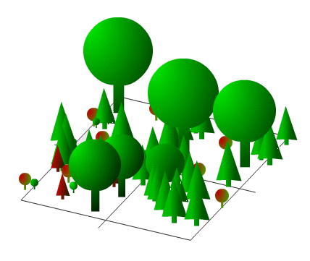

Written by Esther Shartar
Drawings by Nathan Howe

How to Use this Guide

This teacher’s guide consists of 3 units. The first, Tree Trunks, Leaves and Branches, is meant to introduce students to tree biology, anatomy, physiology and identification through field and classroom work. In the second unit, Trees in the Forest students learn how to survey forest plots, and in the third, Forest Growth and Change, develop their abilities to use the SimForest software to investigate questions about forest dynamics.

Though the activities are broken up into numbered units according to type, we suggest that teachers do not keep the three completely separate. Because different students will come to these activities with different skills, interests, and background knowledge (e.g. some students may be most interested in tree biology, others in mapping a plot, and others in using the simulation), interspersing the activities from the different units may help to keep many types of learners engaged. Also, each unit may become richer when used in conjunction with the other two. However we do recommend that students have some class experience with real forests (Unit Two) before working with the software (Unit Three).

Because questions are such an important part of inquiry, this guide is structured by questions. Each discussion or activity is headed by a question, such as “How do trees make wood?” “How do you measure the size of a tree?” and “How does a forest change over time?” Under each of these headings are two lists, one of goals and another of questions that relate to the topic question and may help students build a deeper understanding of concepts and develop inquiry skills. The guide also includes teaching tips and background information to help teachers encourage inquiry and lead discussions and activities surrounding the questions.
We do not expect teachers to use the questions in this guide as a drill, in which students are expected to respond with the correct answer. Rather the questions are intended to help students take part in the process of forming theories and hypotheses, designing investigations, reviewing theories in the light of data or past experience, and asking their own questions. This does not mean that the correct answer is never important. Unit One contains a number of questions that are meant to help students develop understandings of specific concepts. However even in these activities we tried to phrase the questions in a way that emphasizes the process of developing concepts not just on the concepts themselves. For each activity teachers can decide how much emphasis to put on content, and how much on process.
One way that teachers can facilitate the inquiry process is by resisting the urge to answer questions and correct wrong answers. Rephrasing questions, asking new ones, and gently pointing out the flaws in student theories (by asking questions whenever possible) may help students construct valid explanations themselves. However, there are times when a teacher may decide to give hints, suggest other resources or methods, and even answer questions. Such decisions can be made in consideration of the nature of the questions, the teacher’s goals for the activity/discussion, time constraints, or student morale.
Based on each of the questions we suggest there are many different ways that an investigation could go depending on the interests and questions of the students. Some questions and suggestions may even cause the class to pursue topics different than the ones with which it began, and this can be an appropriate outcome as well.
The questions in this guide are by no means meant to be limiting. We encourage students and teachers to use our suggestions or to come up with their own questions to pursue using SimForest or another investigation technique. This guide includes activities aimed at helping students brainstorm questions and design investigations. There is also a form on the last page of the teacher’s guide in which teachers can record interesting investigations that take place in their classrooms in order to send them to us and/or refer to them in future courses.
The questions we suggest serve as examples of questions that may be asked or investigated by a class and a standard by which teachers can assess their own and student questions. This may be especially useful in Unit Three when students are using an unfamiliar tool: the SimForest software.

Unit One

TREE TRUNKS, LEAVES, AND BRANCHES

The questions and activities in this unit are meant to stimulate students’ interests in trees by introducing them to some fascinating concepts of tree biology, such as the way that trees grow by adding a new layer to the outside of their trunk every year, and the fact that they make wood out of carbon dioxide and water. Students participating in the discussions and activities in this unit may learn skills and information such as how to identify a tree, and what factors affect tree growth, that will help them carry out plot surveys in the forest and investigations with SimForest (Units Two and Three).
Some activities in this unit involve interaction with trees and tree parts, some discussions, others library research, and many a combination of the three. More than one topic question may be addressed in the same class period, though some periods may be devoted to examining only one question. For example, the questions “How does a tree make wood?” “If wood is made of sugar why can’t we eat it?” and “Other than air, water and light what else do trees need?” might fit well into the same lesson, while the question, “Which type of trees grow around here?” could fill an entire class period or more.
All questions and activities in this unit are meant to spur inquiry cycles that involve actual and/or thought experiments. We hope that by encouraging students to work together and participate in class discussions, students will be able to learn from and build on one another’s inquiry cycles.
Any of the questions in this unit may be asked by a teacher in order to lead students towards a new concept, but many may also be raised by students. The questions need not be addressed in the order listed here. There are many different ways to structure this unit based on teacher preference and student interest. There is also plenty of room to explore other questions (asked by you or your students) that are not listed here. Following up on student questions in class or through homework not only supports the inquiry process; it may also improve student motivation and lead to some very interesting investigations.
To emphasize the importance of student generated questions, this unit begins by asking students to ponder and communicate what they know and do not know about trees, and to create a list of questions about trees. You may want to have students keep a journal throughout this and the other units, in which they take notes, record data and vocabulary, keep track of the questions that they have, and document the investigations they undertake.

What is a tree?
Goals | Other Questions
Students will be able to ask questions, design investigations, and summarize their knowledge of trees.  * Teachers will also gain a better understanding of student knowledge and interests. | What do you know about trees?  List some questions you have about trees.  What could you do to find answers to these questions?

Teaching Tips and Background Information
This question may seem really basic, but in some ways it is the hardest one in this unit to answer. One reason for this may be that the question is so open-ended. The other questions in Unit One will help to bring focus to the discussion, but for now it is okay for students to think broadly.

This is an introductory activity. Thus, its main purpose is to get students interested in and thinking about the subject matter. The goal does not necessarily have to be for students to develop a concrete definition of a tree, though this may also be one of the objectives.

You may ask students to write in their journals about these questions and then share their ideas with the class. Or, you could start with a class discussion. Whatever you do, consider keeping track (or having students keep track) of their questions and comments.

This activity provides an opportunity for students and teachers to discover and contemplate what they know and do not know about trees. The questions and answers generated here may provide the motivation for future investigations and also help structure the following lessons. These comments may give insight into which sections of the unit you want to skip over or give special attention to.

Some of the questions brought up in this class discussion will invariably be different than the ones listed in this teachers’ guide. Though the questions in this guide highlight some interesting and important concepts, the student-generated questions will also offer learning opportunities in terms of inquiry skills and scientific concepts. Pursuing their own questions can also increase the students’ motivation and senses of ownership and accomplishment.

After a list of questions has been collected and students have discussed techniques for answering these questions, such as researching in books or on the internet, asking an expert, and conducting an experiment, you may suggest that the students divide the questions into groups based on subject matter, how they could be investigated, or importance to the class. Next, each student or group of students could choose a topic to investigate outside of class and report back on during a later class period. These reports could range from a paragraph of explanation to a paper, depending on the teacher’s goals. You may want to encourage or discourage the pursuit certain questions, based on their ability to be investigated in the amount of time given for the assignment.

It may be interesting to ask the question “What is a tree?” again after students have investigated some of the other topics to see if and how their ideas have changed.

How does a tree make wood?

Materials
A piece of a tree [i.e. a cross section of a truck (known as a “tree cookie”), a branch, or a piece of lumber]

Goals | Other Questions
Students will be able to summarize a conceptual understanding of the process of photosynthesis, including its inputs (H₂O and CO₂) and outputs (glucose), and explain what they understand about how wood is made from carbon dioxide and water.  Students will be able to define the terms  - Photosynthesis  - Chlorophyll  - Glucose (C₆H₁₂0₆) | What raw materials did the tree use to make this piece of wood?  Do you think it would be possible for a tree to make this out of CO₂ and water?  What does a tree turn into when it is burned?  What do trees use as food?  What compound makes leaves green?  What does chlorophyll do?  Where does the CO₂ that leaves take in go?  What do trees do with the glucose that they make?

Teaching Tips and Background Information
The purpose of this question is not simply to review or introduce the concept of photosynthesis, but also to help students come to realize the true implications and wonder of this process.

A common misconception is that trees take soil and minerals up through their roots and turn them into wood. This seems to make sense because soil and minerals are solid, as is wood, but this is not really what is happening.

Actually, trees make solid wood primarily out of CO₂ and water (a liquid and a gas). Not only that, but the sub unit of wood is a simple sugar, glucose.

While leading this discussion, it is doubtful that you will need to use all of the listed questions, but they are there to give you an idea of the variety of different ways that you can help students to develop a working concept.

In order to make sure that students understand this process, you may want to follow this activity with an assignment in which students use their creative skills to explain the process. For example, they could write a letter to a (fictional) friend, make an artistic poster, or design a board game - anything that illustrates their understanding of the concept in a creative and interesting way.

If wood is made of sugar, why can’t we eat it?
Goals | Other Questions
Students will be able to form hypotheses to explain why some organisms can eat and digest wood, but humans cannot.  Students will be able to describe the products of photosynthesis (cellulose and starch) with more detail than during the previous discussion  Students will be able to discuss the impact of molecular structure on the digestibility of cellulose and starch. | What is the difference between plant matter that we can eat and plant matter that we cannot?  What is a potato made of? What is bread made of?  Why can we eat and digest a potato and a piece of bread but not a tree trunk?  Can anything eat and digest wood?  What makes an organism able to eat and get nourishment from wood?

Teaching Tips and Background Information

The discussion following this question may take many shapes.

Some students may bring up the mechanical side of eating by suggesting, for example, that we do not have strong enough teeth. This is true. Other animals, such as beavers have large and strong teeth, which they use to chew on trees (mainly the young twigs and new growth).

Other students may point to the digestive side of eating, by suggesting that we cannot digest wood. This is also true. Potatoes are made of starch, which we can digest because we have the enzyme amylase to break it down. Wood is made of cellulose. We cannot digest it because we do not have the proper enzyme, cellulase, to break it down. Fungi and some protozoa do have this enzyme, which makes them capable of digesting wood (and they do not even have teeth!)

Beavers themselves do not produce cellulase. It is true that their teeth enable them to take the wood into their bodies, but once it is there the digestion of it depends on protozoa that live in the beavers’ stomachs.

Both cellulose and starch are made of chains of the same subunit: glucose, but they are bonded together differently, and this difference in structure is what gives the molecules their unique characteristics.

Even though our bodies cannot break it down (actually, because we cannot break it down), it is good for us to ingest some cellulose. The dietary fiber listed on nutrition information panels is none other than this molecule!

Extension: WHAT HAPPENTS TO BREAD IN YOUR MOUTH?

Materials
A loaf of white bread
Popsicle sticks (1 for each student)
Give each student a small piece of bread. Ask them to make predictions (or describe from past experience) how it tastes, and predictions what will happen to it if they hold the bread in their mouths but do not chew it. Ask them to try this experiment and describe what happens.
(They should feel it dissolve and then turn sweet due to the breaking of the starch molecules.)
Ask them to go through the same process (including predictions) with the Popsicle sticks and compare and contrast the results.

Other than air, water, and light, what else do trees need?
Goals | Other Questions
Students will be able to list the factors, such as light, climate and soil characteristics, which affect tree growth and forest composition.  Students will be able to discuss the fact that different species of trees have different requirements in terms of these factors. | What do roots take in besides water?  Can a palm tree survive outdoors in Massachusetts? (Why not?)  Are the tree species that grow in a swamp different than the species that grow in dry soil? What is different about these species?

Teaching Tips and Background Information
Some of these factors may have been mentioned in the discussion of how trees make wood, but it may be good to discuss them again so that students know that even though wood is made primarily out of carbon dioxide and water, trees also need other things in order to live.

The effects and connections introduced here will come up again when students use the SimForest software. The software allows students to change the site properties, which include soil depth, soil texture, soil fertility, average monthly temperature, and average monthly rainfall. Introducing these factors now may help students to use them more effectively later on.

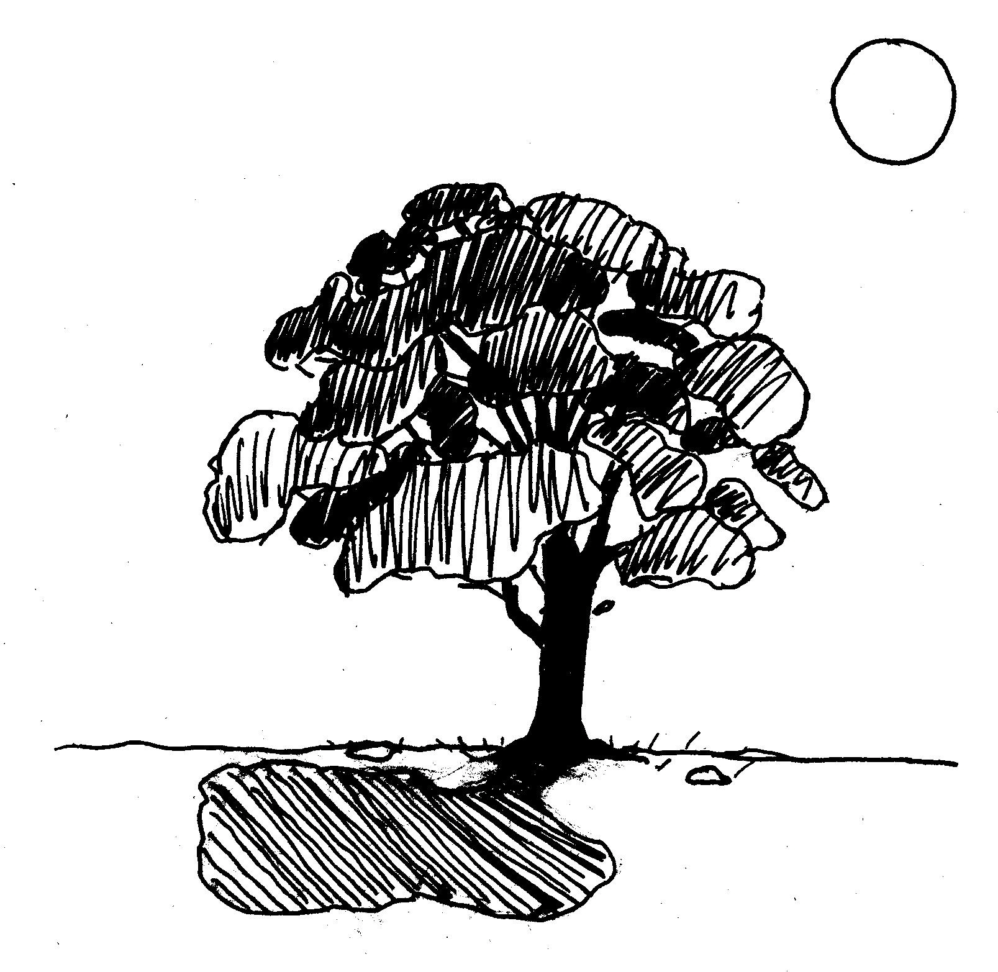

How old is a tree’s trunk?

Materials
A tree cookie, or a tree stump

Goals | Other Questions
Students will be able to explain that  Tree growth occurs in the outer layer of the trunk (the cambium) just under the bark.  - The living part of a tree is on the circumference of the trunk (beneath the bark).  - The inner wood in a trunk (the heartwood) and the bark is dead.  Students will also be able to describe the implications of the above information: 1) In a 200 year old tree the only part of the trunk that is 200 years old is located at the center of the heartwood, and this part has been dead for around 195 years! 2) The living part of the tree is no more than 5 years old! | Is the whole trunk that old?  If not, which part of the trunk is the oldest?  As a tree gets bigger where does the growth occur? (In that case which is the oldest part?)  The very center of a tree trunk is called the heartwood. Our hearts help to circulate blood and nutrients through our body. What function does a tree's heartwood serve?  What does it mean to be alive?  Are there parts of our bodies that are dead (hair, nails outer skin)  Is a tree’s heartwood alive?  Is the bark alive?  Which part of the trunk is alive?  How old is this part?  How old was the oldest part of the tree when it died?  Which is more damaging to a tree: boring a hole all the way through it or making a small cut all the way around the circumference?

Teaching Tips and Background Information
Some common misconceptions are that a trees entire trunk is alive, that the heartwood contains the vascular tissues that transport nutrients and water, that the outside of a tree is dead while the inside is alive and that growth occurs throughout the stem.

In reality the cells on the inside of a tree are dead and the outside cells are alive. Not only does the circumference of the trunk contain the growing tissue of the trunk (the cambium), it is also where all the functioning vascular tissues (xylem and phloem) are located. Cambium and phloem cells are constantly sloughed off and replaced, but xylem cells can live for at most about 5 years.

In a discussion format, the teacher may have to tell students some of the information in this lesson, such as that the inside of the tree is dead. Students may be able to construct some of the concepts themselves.
For example, talking about tree rings and why trees have them may help students to think about where trunk growth occurs.

Once students have constructed the concepts, or had the concepts explained to them, they should be able to discover the implications for themselves. The last 3 or 4 questions in the other question list are meant to help students realize these implications.

Another way to lead this activity is to have the students answer the questions in their journals (complete with explanations of their answers) before giving them any hints or information.
If you choose this method, ask students to do book or internet research on the questions for homework and write new answers if they would like (but also keep the old ones).
In the following class students could discuss their first hypotheses, where they looked for answers, and what they found through research, thereby dispelling their own misconceptions and teaching each other.

Extension: If you nail a bird house 5 feet up in a young tree, How high will it be in 50 years?
Goals | Other Questions
Students will be able to use their problem solving skills to solve a riddle.  Students will be able to explain that growth upwards occurs at the top of the trunk, not the middle or bottom of the stem. | How could you investigate this question without waiting 50 years?  Think about other things you have seen attached to a tree like a swing or a sign. In your experience have they moved up over time?
Teaching Tips and Background Information
A common misconception is that a tree’s upward growth occurs at the bottom of, or all throughout, the trunk.  In reality, all lengthening of the trunk and branches occurs only on the tips of twigs where the meristematic, (e.g. growing) region is located.  Instead of just explaining this concept to the students try to help them draw on their previous experiences and knowledge in order to figure this concept out for themselves. If they do not understand it right away, this riddle could be left for students to think about over the course of their work with questions in this guide.  Later, when the class goes on walks in the woods you may want to point out examples of things which have been attached to trees for a number of years, such as barbed wire, signs, or even carvings in the bark, and ask students if they think these things have moved up over time. | 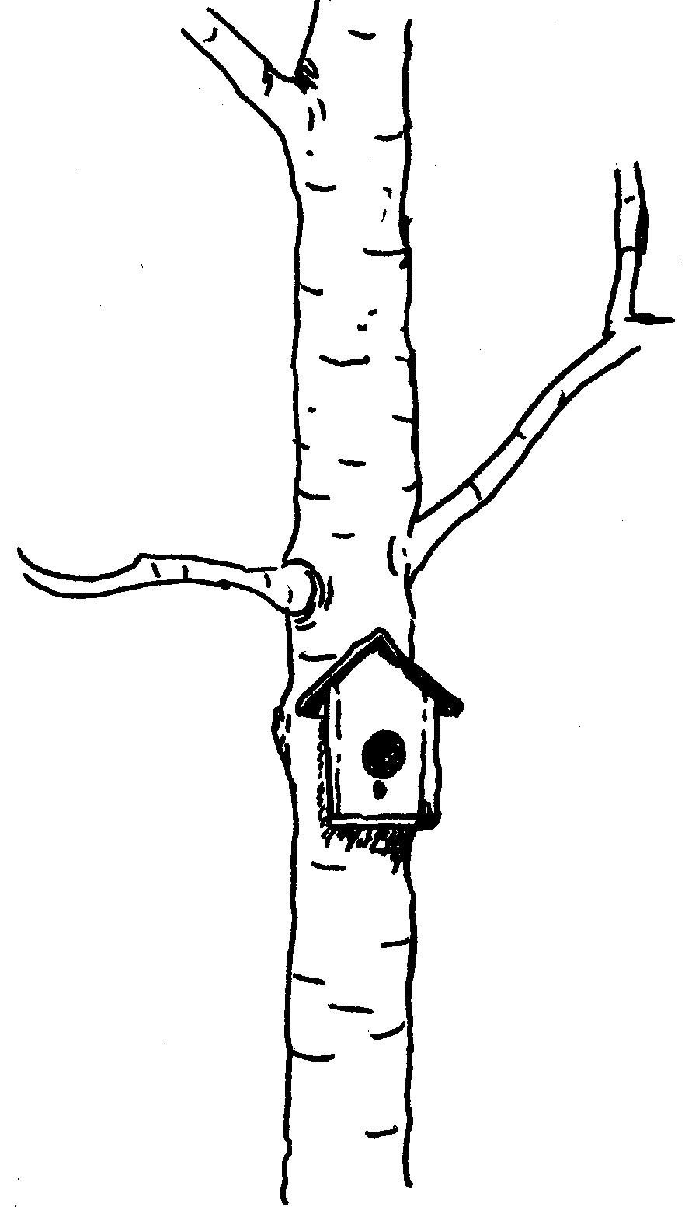

How much does a tree grow in a year?
Materials
Tree cookies, tree cores, or tree stumps with clear rings
Graph paper
Pencils
Rulers

Goals | Other Questions
Students will be able to make graphs, known as dendrograms, to illustrate the growth of a tree’s radius over time, and how the growth rate varied from year to year.  Students will be able to explain why  - Trees in colder climates have rings. (The growing season varies throughout the year. Cells that are born in spring are larger and lighter in color than the ones that are born in summer and autumn, and in winter cells are not born at all.)  - Trees in regions with a less varied climate do not have rings.  - A tree’s rings vary in size based on growing conditions. | What does a tree ring indicate?  What can you learn from a tree ring?  Why do trees in New England have rings?  Do trees in warmer climates have them? (Why not?)  Why are the different rings different sizes?  What factors might affect how a tree grows?  What tools and process could you use to make a graph of a tree’s radius over time?  What if you wanted to graph the growth rate of a tree over time?  What would the X and Y-axes stand for? What would the units be?
Teaching Tips and Background Information
Concrete evidence of how trees grow by adding to the circumference of their trunk each year can be seen in a tree’s rings. Tree rings also illustrate the effects of climate on tree growth. Thus, an examination of tree rings may help to reinforce both these concepts.

It is relatively easy to make a graph of a tree’s radius (distance from the center to the outside ring) over time. Students can make them using a tree stump, cookie or core, graph paper and a pencil.

Making this type of Dendrogram does not even require that you make any measurements because the tree rings themselves can serve as the ruler.

Method
Begin by drawing and labeling the X and Y-axis. Each square on the X-axis stands for a year, and the Y-axis measures the radius of the tree (actual size). Next, line the center of the tree up with the origin of the graph so that the rings are perpendicular with the Y-axis. Keep the center of the tree on the X-axis (Y=0) and the rings perpendicular to the Y-axis at all times during this activity. Make a dot where X=1 (year one) and the radius after year one (the width of the first ring measured on the Y axis) intersect. Make a dot where X=2 (year two) and the radius of the tree after 2 years (the width of the first 2 rings measured on the Y axis) intersect. Continue with year 3, 4, etc. until you get to the bark of the tree. By connecting all of the dots you get a growth curve for the tree! (See figure). To make it easier for them to see the rings while they are graphing, students can first mark off each ring on a piece of paper and then use the paper, instead of the rings themselves, to measure the radius on the graph.
If the year that the tree was cut or cored is known, students can also label the years on the X-axis by counting back from the year it was cut.

A Partial Graph of Tree Radius against Time
Made Using a Tree Core, (Reproduced to the Right)
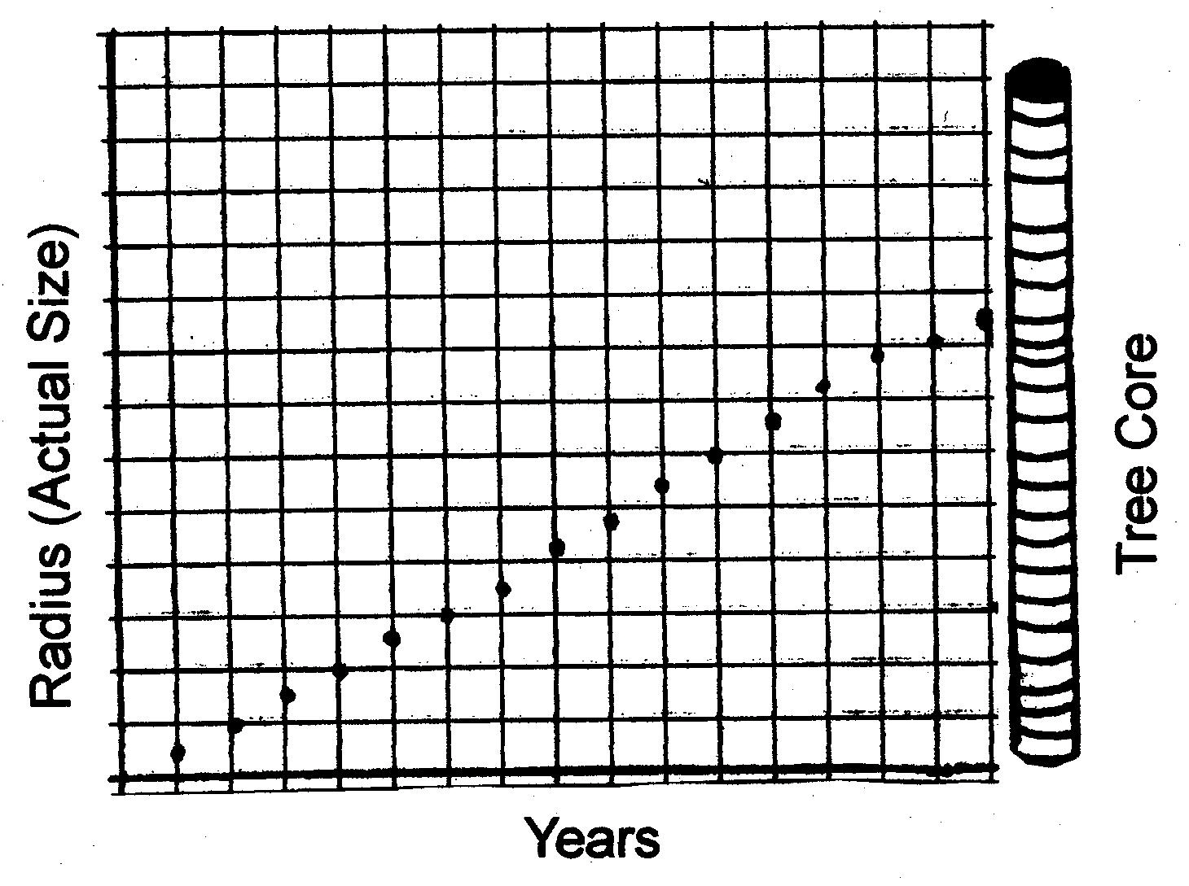

Students can also create a graph of growth rate over time by graphing the width (in mm) of each ring against time in years.

At some point, either before or after making graphs, it may be interesting to lead student in a discussion about why trees have rings, and what the rings tell us about trees and their environment.

Extension: HOW MUCH LENGTH DOES A BRANCH GAIN IN A YEAR?
Materials:
Tree branches with clear terminal bud scars
Goals | Sub Question
Students will be able to determine how much a tree’s branch grew in a year by measuring between the terminal bud scars. | Where does growth occur on a branch?  How could you measure how much a twig grows in a year?
Teaching Tips and Background Information
Because the lengthening of tree branches occurs at the terminal bud, students can also determine how much a tree branch lengthened in a year by measuring the distance between the terminal bud scars
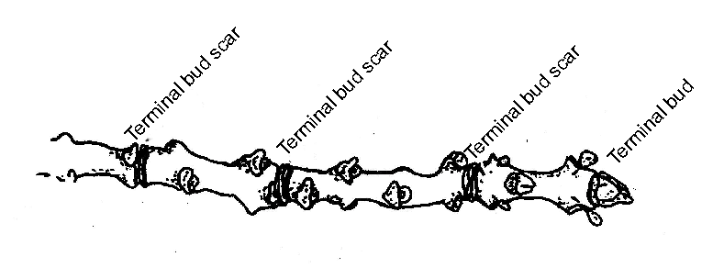
A branch with clear terminal bud and terminal bud scars

WHY DO TREES LOSE THEIR LEAVES?
Goals | Other Questions
Students will be able to form and discuss hypotheses about  - Why trees lose their leaves before winter.  - What triggers leaves to fall.  - How conifers have adapted to the challenges of winter without losing their leaves.  Students will be able to describe how trees lose their leaves through an active process of abscission and explain a theory of why some trees, such as red oaks, hold on to their leaves after they have turned brown. | What is the purpose of leaves?  Why do they fall off in the autumn?  What makes them fall?  What triggers a tree to lose its leaves? (How would you study this?)  Why do the leaves of some trees, like red oaks, turn brown but not fall off?  Do conifers have leaves?  How have evergreen trees adapted to the issues of winter without losing their leaves?  What are the advantages of keeping leaves over the winter?  What are the disadvantages?
Teaching Tips and Background Information
Most of the above questions have a number of possible explanations. Thus you may want to ask students to generate multiple hypotheses for each question.

Some hypotheses for why trees lose their leaves that were generated in a model class were:
- To conserve water and energy
- To collect less snow (and prevent breakage due to weight)
- Because there is less sun and therefore less possibility to photosynthesize
- To shed parasites
All of these may be benefits of shedding leaves.
A common misconception is that trees lose their leaves because an outside force, such as wind or rain knocks them off.
In reality, trees actively form an abscission layer, or layer of cells that separates the leaf from the branch, and when this layer is complete the leaf falls.

Some hypotheses about what triggers leaves to fall were:
- Day length
- Sun angle
- Temperature
Scientists have done research on this subject and found that day length (or more correctly night length) appears to be the main trigger. Leaves contain a chemical called phytochrome, which exists in two forms. It changes into one form in the light and decays into the other in the dark. Based on how much of the first form is left in the morning, the leaves “know” how long the night was, and at a certain night length (this can be individual for each tree or species) the tree begins to form the abscission layer.

In New England, red oaks are at the northern end of their range. Down south, their leaves do fall, but here the temperature becomes too cold (and the cells stop growing) before the abscission layer is complete.

Other trees, such as pines and hemlocks, keep their leaves over the winter. In order to survive the difficulties of this season they have developed other adaptations, such as waxy leaves and slender needles.

Brainstorming on this topic may help students think about the various adaptations that can develop in response to the same environmental condition.

Extension: DO CONIFERS EVER LOSE THEIR NEEDLES?
Materials
Pine boughs with needles attached
Goals | Other Questions
Students will be able to determine how old a pine needle is by counting the whorls. | How old can a pine needle get before it falls off?  How would you figure this out?
Teaching Tips and Background Information
The most recent pine needles are the ones closest to the tip of the branch; the oldest are the ones furthest down the branch. To determine the age of a whorl (and therefore its needles) count back from the most recent whorl. You may want to compare boughs from more than one tree.
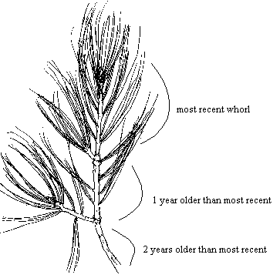
This branch was collected in the spring before any of this year’s needles had grown. That means that the needles on the most recent whorl are almost one year old, and the needles on the second whorl are almost two years old. The needles from 3 years ago have already fallen off.

HOW CAN YOU TELL TREES APART?

Materials
A tree branch that will be readily identifiable by students.

(In the summer, maple or oak with leaves or a pine branch will do. In the winter an oak with clinging leaves, or a white pine bow serve nicely. White pine is especially useful in either season because it can be easily identified to the species level, while it can be more difficult to distinguish between the different types of oaks or maples even when their leaves are intact.)
Goals | Other Questions
Students will be able to distinguish between different parts of a tree.  Students will begin to be able to identify trees based on their characteristics. | What kind of tree is this?  How do you know?  What are the distinguishing characteristics of a tree?

Teaching Tips and Background Information
A list of tree characteristics generated in a sample class looked like this:

Form
- Branching pattern
  - Alternate for oaks, beech etc.
  - Opposite for ash and maple
  - Whorled for conifers
- Shape
- Size
Leaves (remember needles are leaves too!)
- Shape
- Number
- Size
- Color
Bark (changes with age)
- Pattern and texture
- Color
Buds (useful in spring and winter)
Flowers (You may want to ask a question like “Do trees have flowers? What do they look like?”)
- Gymnosperms (mainly conifers) have naked seeds in cones
- Angiosperms (mainly deciduous) have covered seeds.
Fruit (You may want to ask: “Do trees have fruit?)
- Maples –“helicopters”
- Oaks – acorns
- Gymnosperms seeds in cones, sometimes berries (Juniper)

The students in your class may not come up with all of these characteristics, but by looking at the tree samples, they will come up with some of them. You can mention some of the characteristics that students leave out, or allow this to be a partial list.

You may also want to bring in a number of branches of different types and ask students to describe them in detail in their journals. You could also bring in a couple branches of the same species and ask students which branches are from the same species, and how they know.

Both of these activities may help students to notice the features and characteristics of a tree, as well as the similarities and differences between the different species. These activities may also provide a context in which students are motivated to learn the vocabulary.

WHY AREN’T THERE TREES WITH MAPLE SHAPED LEAVES AND ACORNS?
Goals | Other Questions
Students will able to define the term species. | Why are all these traits (form, leaves, bark, flowers, fruit) so correlated within a type of tree?  Can a maple breed with an oak? (Why not?)  Aren’t their some different species that do interbreed?
Teaching Tips and Background Information.
In a sample class the responses that students gave to this topic question were somewhat circular at first. For example, “Maples have certain characteristics and oaks have other characteristics.” Comments such as this did not get to the heart of the question, which is, why is there a difference between oaks and maples to begin with?
When we asked students to dig a little deeper, one student responded that they are unique because they are different species and cannot interbreed because they have different pollen receptors and incompatible DNA.

Sometimes the line is a little bit fuzzy. There are examples of species that do interbreed, for example red and black oaks, but in general the rule that an organism can only breed with members of its own species holds true.

Extension: BUT WHAT’S IN A NAME?
Goals | Other Questions
Students will be able discuss the politics of species classification. | Does it make any difference whether or not an organism is labeled as a distinct species?  How might classification affect environmental policy?

Teaching Tips and Background Information

Students may be interested to know that people and organizations interested in protecting endangered wildlife and habitat often work to get unique breeds or communities of animals to be labeled as a separate species because once an organism has species status it can be placed on the endangered species list at which point it is more likely to be protected. On the other hand, people and corporations that want to use protected resources often lobby to group more organisms under the same species name.
Sometimes species go on and off of the endangered species list not because of a change in their numbers, but rather a change in their classifications as species.

Extension: ARE TREES INDIVIDUALS?
Goals | Other Questions
Students will discuss the concept of individuals of a species as it pertains to trees and humans. | Look around the room. Are all of us members of the same species?  Can you distinguish your classmates from each other? Are your classmates individuals?  Are trees individuals?  Can individual trees be told apart? (Why or why not?)

Teaching Tips and Background Information
These questions are somewhat more philosophical than some of the others and may result an interesting discussion.
Some tree species sprout from the roots, thereby creating clones or trees with the identical genetic make-up.
You may want to ask students if a cloned tree is less of an individual than a tree that is genetically unique. Also, would cloned trees look more similar than trees with different genes? What about the effect of the environment? Are human clones (identical twins) less of individuals than other humans?

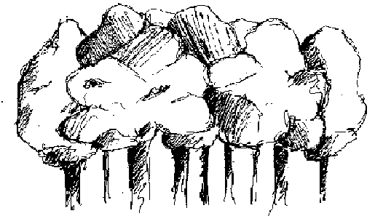

WHICH TYPES OF TREES GROW AROUND HERE?
Materials:
For collecting and labeling twig samples:
Pruning shears
Masking tape
Permanent markers
For making bark (and leaf) rubbings:
Paper
Soft pencils or charcoal
For taking notes:
Student journals

Goals | Other Questions
Students will be able to list and identify some of the tree species that grow around them. | Do you recognize any of these trees? What trees are they?  What examples of different types of bark do you see?  How about examples of different branching pattern (and buds, leaves, or flowers - depending on season)?
Teaching Tips and Background Information
Identifying trees can seem like a daunting task, but once you know what to look for and have had a little practice it is not so hard. Prior to leading this activity, you may want to get some experience with tree identification and familiarize yourself with the appearance and characteristics of some of the local trees, as this may make it easier for you to help your students.

This activity is meant to introduce students to the steps and techniques of tree identification:
- Seeing certain parts.
- Knowing the various shapes and sizes of these parts.
- Assembling suites of these parts.
- Knowing the “tricks” and obvious trees.

You may want to start this class with a discussion in which you and the students agree on goals and methods for the walk.

Review the tree characteristics that you learned in the activity on telling trees apart, but this time be more specific about what each feature means and connect the characteristics with species.

For example, it will be helpful for students to know exactly what is meant by opposite and alternate branching pattern, as well as the fact that maples and ashes are the only species New England forests to exhibit opposite branching pattern. Thus, if a tree has opposite branches, it is either an ash or a maple. Ashes can be distinguished from maples by their rough, “diamond pattered” bark, and you can sometimes also tell maples apart by their bark (for example red maples generally have rougher bark than sugar maples).

Some species are especially easy to identify. These include beech, yellow birch, and black birch. (Distinguishing between paper and gray birch can be more difficult.)

You might suggest that students take notes in their journal or notebook about tree identification tips and “what to look for” so that they can refer to them during the walk.

On the walk, ask students to take note of interesting bark patterns and color, branching pattern, leaves, buds etc.

Students can take rubbings of bark with interesting texture, and clippings of interesting twigs. It may be useful for students to label the samples they collect. If you know the name of a tree that students are sampling you may want to tell them, but students can also guess the species name and include some other characteristics of the tree.

Students will be able to use the samples with known species names as references later, and it they want to use a guidebook to identify the unknown samples, having a hypothesis and list of descriptions may prove very useful.

Unit Two

TREES IN THE FOREST

The main purpose of this unit is to get students into the woods and asking questions of the trees themselves by surveying a plot. The activities found in this unit expand on the previous unit by bringing the concepts into their real world application: the forest. These activities also provide students a true context for their subsequent work with the SimForest software by giving students an idea of the size of a 10 x 10 meter plot, as well as the number and types of trees that might be found on such an area. In our trials of the software we found that students who had spent class time surveying a forest plot before beginning work with SimForest were more effective at using the software and appeared to get more out of the simulation than students who had not had such an experience.
Though this unit is broken into just 2 activities, students could spend weeks investigating them. Because surveying a plot is an active, hands-on activity, it may help to draw students more deeply into their study of trees and forests. For this reason you may choose to begin this activity early on in their investigations of trees, before they have finished their work in unit one. Students may also continue to work on surveys after they have started investigating the questions in Unit Three. One way to structure your classes would be for students to spend one day a week outdoors surveying plots and the rest of the week in the classroom engaged in investigations from Units One and Three.
The structure of Unit Two is more linear than Unit One: Students should understand how a tree’s size is measured before they go into the field, and they must survey a plot before they can map it. However, this unit could be shortened or expanded. In the barest version, students would simply identify (and record) every tree on plot. A more in depth investigation would also include measuring and recording each tree’s diameter at breast height (DBH). In the most advance version of the unit, students would record species and DBH and map the location of the trees on the plot. Students could also survey more than one plot, in order to compare different plots with different compositions and characteristics.

HOW DO YOU MEASURE THE SIZE OF A TREE?

Materials
Measuring tape
Yard/meter sticks

Goals | Other Questions
Students will be able to measure a tree’s circumference at breast height.  Students will be able to convert circumference at breast height to diameter at breast height (DBH), which is a standard measurement of tree size. | One standard way that foresters estimate the size of a tree is by measuring its diameter at breast height (DBH). How would you measure DBH?  What if the tree is not round?  Why do foresters measure trees at breast height?

Teaching Tips and Background Information
One way to begin this activity is by asking your students to brainstorm ways of measuring a tree. Then introduce them to the standard measurement of forestry: diameter at breast height (DBH), and ask them to brainstorm how they would take that measurement.

In our region, tree trunks are flared at the bottom, but have pretty much straightened out by about 3 to 4 feet up; Thus breast height a good place to measure. However, such a standard would not work so well in the tropics where trees have much larger and taller buttresses.

You may want to introduce students to the method of measuring DBH in the classroom so that they will have strategies planned once they get into the woods.

One way to measure DBH is to hold a yardstick up the trunk so that it is parallel to the ground and read off how wide the trunk is. However, if the tree is not round this method can be inaccurate.

A more accurate method is to measure the circumference and then convert it to diameter.
Remember: C = πD (Circumference = pi times Diameter), and therefore D =C/π
There are actually DBH measuring tapes that do this conversion for you by measuring in cm/π or in/π, which makes it possible to wrap the tape around the circumference of the trunk and read off the diameter.

HOW DO YOU MAP A PLOT?

Materials
In the plot:
Measuring tape
Clip boards with graph paper (for recording data)
Pencils
Compasses
Flags and/or marking tape (to mark edges of plot and measured trees)
Yard sticks (if you want to measure tree height)
In the classroom:
Rulers
Pencils
Graph paper
Protractors

Goals

Students will be able to
- Identify trees
- Measure trees and distances
c) Map a plot

Teaching Tips and Background Information
Depending on the size of your class you may want to divide the students into teams to survey one or more plot(s).

You may want to begin by having students use the measuring tape to map out the edges of the plot. In SimForest, the plot is 10 meters by 10 meters. Surveying an actual plot this size may give students some context for interpreting the model.

If you and your students have decided to record only the species or the species and diameter for each tree have students do this now.

If you have decided to map the plot, start with a center point and then measure each tree’s distance and compass bearing from that point (See Figure)

Set up the data table for this type of plot like this:

Tree ID #
Species
DBH
Distance from Center
Compass Bearing

1
Hemlock
10cm
3.2 m
45º

To turn this table into a map, begin by deciding on a scale and marking out the borders of the plot on the graph paper. Next, draw in the center point and an arrow pointing north. Using the protractor, measure the bearing of the first tree from north on the map and the ruler and scale to mark out the distance of the tree from the center along that bearing. Repeat this for all of the trees in your plot. You may also want to draw the tree trunks to scale and use a color key to indicate their species.

Extension: WHAT IS THE SOIL IN YOUR PLOT LIKE?

Materials
Garden shovels
Goals | Other Questions
Students will describe the texture of the soil in their plot using qualitative observations. | What does the soil feel like?  Would you describe it as sand, silt, clay, something else, or a combination? If is a combination, how much of each component do you think the soil contains?

Teaching Tips and Background Information
A very quick and easy way to get an idea of the soil texture of your plot is to dig a hole about 2 feet deep and feel the soil inside with your hands.
Ask students to make qualitative observations of the soil (color, texture etc.) and make an educated guess about where the soil falls on the sand – clay continuum.

Grainy = Sand
Fine = Silt
Very Fine (and often wet and pasty) = Clay.

Tell students to record their observations in their journals.

The SimForest program allows users to set soil texture, so this information may prove useful later on.

Unit Three
FOREST GROWTH AND CHANGE

This unit is meant to scaffold students’ investigations with the SimForest software. Throughout their work with this tool, you may want to have students work at the computers in teams of 2 to 4 students (I will henceforth refer to these as computer teams). The first time that students open the software they will have a lot to get used to in terms of visual displays and variables that they can manipulate. Students will need time, sometimes an entire class period, to play around with these features and variables without having to stick to a rigid experiment or technique. At the same time, it may be difficult for them to learn how to use the software without guidance or an introductory activity to lead them through using some of the features. Do not worry about introducing students to all aspects of the software on the first day because once they get the idea of how to use it, most students will explore the software on their own or ask questions about the different features as the need arises.
After students have been introduced to the model, you may want to review the questions that they generated during their work in Units One and Two to see if any of these questions could be examined using SimForest. Students should also brainstorm new lists of questions to investigate using the simulation. Subsequent investigations can involve both the questions students ask and the ones presented in this guide.
Investigating many of the topic questions in this unit could easily take up an entire class period or even longer, though some such as, “Does the simulation always yield the same results?” may take up less time and could be included as part of one of the other introductory activities. In the first few activities (leading up to and including “Can we simulate the plot we surveyed?”) all of the questions listed under each heading are meant to be explored together as part of the same investigation.
In later activities (from “How does temperature affect forest composition?” through “How do ‘natural disturbances’ affect forests”), though the questions included under each heading involve similar themes, many could be explored individually. We do not expect that students will investigate every question in a given category. Rather that they will choose the one(s) that interest them most and/or explore questions that they have come up with themselves. You may want to encourage a few computer teams to investigate the same, or similar, questions so that they will be able to compare hypothesis, methods, results and conclusions.

Using SimForest: Helpful Features and Information
Students may find the following information useful in their work with SimForest. These features are not meant to be the focus of a lesson. They are listed here to give teachers an idea of some of the different aspects of the software so that they will be able to introduce students to these tools and explanations as the need for them arises. This information is also meant to help teachers explain units, terms, and abbreviations that might be confusing and unfamiliar.

Features
Overhead Scroll Over  By scrolling over the trees in overhead view you can gain useful information including  Height (Hgt)  Diameter (Dmr)  Species  Age  Site Quality (SQ) – A number between 0 and 1 that quantifies the  suitability (in terms of soil nutrients, water, and temperature) of a site  for that species of tree. The higher the number the more suitable the  conditions.  Light Factor (LF) – A number between 0 and 1.45. It is calculated from  the shading leaf weight (number and type of trees growing above the  tree in question), and the light response of the species (shade tolerant,  intolerant, or intermediate) The larger the number the more suitable  the light conditions are for the scrolled tree.  Growth Rate (dD)  * You can also get some (but not all) of this information by scrolling over trees in the orthogonal view. | 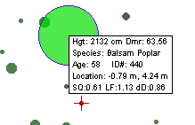
Tree Inspector  By clicking on a tree once in the overhead or orthogonal view, you will bring up the tree inspector. In the tree inspector you can  - Change the species, age, diameter, and location of the tree you clicked on.  - Remove the tree from the plot | 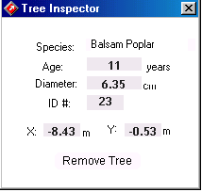
Saving Functions  The Save Snapshot button allows you to save the current state of the simulation and the current settings of the properties and seed pool.  The Load Snapshot button allows you to open a snapshot in SimForest that you have already saved.  The Export Plot History allows you to save all of the tree data (species, number of stems, DBH etc.) that have been generated by the simulation since the last resetting of the plot. This cannot be opened again in SimForest, but it can be opened using the forest analysis tools. These tools help you graph the data using excel. | 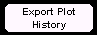

Seed Pool, Nursery, and Manager  In the Manager you can  - Reset the plot (i.e. return to an empty plot). This feature does not reset any changes you have made to the seed pool or properties windows  - Turn recruitment on and off. “When Recruit On?” is checked, new trees can come on to the plot, when it is not checked, no new trees can seed in.  - View graphs of height vs. available light and number of trees.  In the Seed Pool you can  - View a list of species for which the model has equations.  - Remove a tree from the seed pool (prevent it from growing) by clicking on it and turning it red. (To restore a species to the seed pool click on it again to turn it black.)  In the Nursery you can  - View a list of species for which the model has equations.  - Select a species to plant by clicking on it. (This only works if the species is selected and planted in overhead view.)  - View the maximum height, maximum diameter, and growth rate for the species selected. | 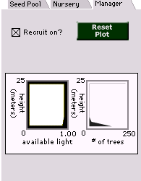
Temperature (Properties Window)  The temperature graph displays average monthly temperature in Celsius.  You can change the temperature by dragging each month’s temperature with the cursor, or by clicking on + and – buttons to move the whole profile up or down. The value that gets plugged into the growth equations can be found in the degree-days box.  365  Degree days = Σ (T_{d} – 7.2 º C)  d=1  Or, the sum of the daily temperature (T_{d}) minus 7.2 ºC (the temperature at which trees stop growing) as d (day) goes from 1 to 365 (1 year). | 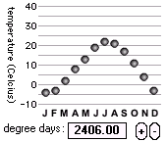
Rainfall (Properties Window)  The rainfall graph displays average monthly rainfall.  You can change this rainfall the same way you change the temperature, by dragging each month’s rainfall individually or clicking on the + and – buttons to raise or lower the whole profile.  The value that gets plugged into the growth equations is the average yearly rainfall, which can be found in the average rainfall box. | 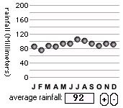
Soil Sliders (Properties Window)  All of the soil sliders can be changed by dragging the slider with the mouse.  Soil Fertility is a fertility index measured in units equivalent to  grams of nitrogen per hectare (10,000 m²)  Soil Texture, measured in mm water / m soil, tells how much water can be held by the soil. (e.g. how clayey or sandy the soil is.) A soil texture of 25 is sandy. A texture of 250 clayey.  Soil Depth measures the centimeters of soil above the bedrock. | 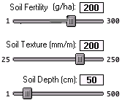

Other Information
Some Simplifications of the Model  Location  A tree’s location on the plot does not matter. In the simulation, every tree shades or is shaded by every other tree equally regardless of their proximity to each other.  Trees and the Environment  In this model the environment (climate, light soil) determine tree growth. Tree growth determines available light but has no impact on climate, water, or nutrients (i.e. roots do not increase the soil’s ability to hold water, and nutrients are not lost when trees are cut.) | 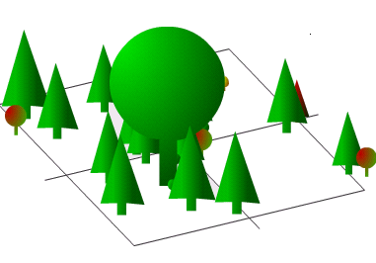
Growth Equations  In this equation, the increment of growth is proportional to the diameter of the tree, the growth rate, the closeness of the diameter to the maximum diameter, and the suitability of the site for that tree. This means that when at tree is significantly smaller than its maximum diameter, its growth rate increases with an increase in diameter, but as the trunk nears its maximum size the rate of growth decreases. Also, the more the suitable the site is for the tree (i.e. the closer the, water, temperature and soil nutrient factors are to 1, and the light factor to 1.5) the greater the yearly growth rate. | The Growth Equation:  dD = G * D * ( D_{max} – D) * Lf * Tf * Wf * Sf  D_{max}  dD = change in diameter over time  G = optimal growth rate (specific to each  species and based on field observations)  D = diameter  D_{max} = the maximum diameter (specific to each  species and based on field observations.)  Lf = light factor*  Tf = temperature factor**  Wf = water factor**  Sf = soil nutrient factor**  *Values range between 0 and 1. 45 where 0 = least favorable and 1.45 = the most favorable. Calculation based on available light and species response.  **Values range between 0 and 1, where 0= least favorable conditions, and 1= most favorable. Calculation based on site properties and species response.

HOW DO YOU USE THE SIMFOREST PROGRAM?
Goals | Other Questions
Students will be able to use some of the basic features of SimForest, such as the start and stop buttons.  step back rewind stop run ½ time ¼ time step  Students will be able to navigate the different views and windows (overhead, orthogonal, properties, and summary), and describe how each view or window is useful.  Students will be able manipulate some of the different variables, such as temperature and soil, in an open-ended manner.  Students will be able to make qualitative observations of the simulation.  Students will be able to describe how the different properties affect the about of soil water on the plot. | What happens when you press the play button? (Please describe.)  What information can you get from watching the simulation in the overhead and orthogonal views?  What information can you get from scrolling over the trees with your cursor?  What information can you get from watching the simulation in the summary view?  What are the advantages of the different views?  What happens when you press the reset plot button  What can you learn from the properties window?  Change some of the soil and climate characteristics and reset the plot. Does it change the species composition of the plot?  What happens to the graph of soil water when you change each of the properties? Why?
Teaching Tips and Background Information
The purpose of this activity is to lead students through some of the features of the software, and give students time to learn how to use them by participating in open-ended, investigations. Since students are using this tool for the first time, they need not be systematic or organized in their investigations They have a lot to learn about the tool itself, before they begin using it to study forests.

Because there are so many features of SimForest to explore, you may want to write some of the questions listed here on the board and ask students to pursue them with the software and then write about what they discover in their journals. After students have investigated the questions listed above, allow them continue exploring the software in an open ended manner and recording their observations in their journals.

Towards the end of class, lead a discussion in which students share what they discovered about the software. You may want to leave time for students to try out some of the features that their classmates discovered.

HOW DOES A FOREST CHANGE OVER TIME?
Goals | Other Questions
Students will describe how the modeled forest goes through stages of succession as it matures.  Students will be able to define the terms climax forest and pioneer species.  Students will be able to interpret a graph of available light vs. height, look for correlations between available light and forest composition and describe how available light might affect forest composition and vice versa.    Graph of available light vs. height  Students will be able to make and interpret a graph of forest composition over time. | How does the plot change over the course of a run in the simulation  In the simulation, which trees come in first on a developing plot?  Which ones come in later?  Do the tree species that come in first continue to grow on the plot? (If they die out do they ever come back?)  Do the species that come in later on in a plot continue to grow there?  What might cause these changes to occur on a plot?  Look at the light vs. height graph. How does the shape of this graph change with time?  Do the changes in the available light vs. height graph correlate with the changes in forest composition? How might the forest composition affect available light? How might available light affect the forest composition?

Teaching Tips and Background Information

Begin by asking students to make qualitative observations of their plot over time by using the overhead and orthogonal views and summary window. Tell them to record in their journal which trees come in first, which die out, which come in later, and whether the ones that die out ever come back.

Direct them to the available light vs. height graph. Ask students to observe how the shape of this graph changes over time and look for a correlation between changes in available light and changes in forest composition. If there is a correlation, ask students to explain why this correlation exists by describing how each factor might affect the other.

This activity is a good time to introduce students to graphing by having them choose one aspect, such as DBH, number of stems or total basal area, to graph against time for the species in their plot. Different computer teams could graph different aspects, or focus on different species and then compare graphs with each other. Encourage students to take note of how the quantity of each species changes over time and ask them to identify and describe any trends that they see.

At some point during this investigation, introduce students to the terms succession, climax forest and pioneer species.

You may want to have students write up a short report in which they discuss their observations, graphs, and understanding of succession.

Extension: WHICH TREES WILL MAKE UP THE FUTURE CANOPY?
Goals | Other Questions
Students will be able to apply the understanding of succession that they gained from SimForest, and make observations of the forest’s under-story in order to predict which species will dominate the forest canopy in the future? | Will the same trees dominate this forest in the future? (Why or why not?)  If the large trees in this forest died, which species might replace them? (Hints: Which species dominate the under-story? Has anything similar happened in SimForest? )  How could we model this using SimForest?

DOES THE SIMULATION ALWAYS YIELD THE SAME RESULTS?
Goals | Other Questions
Students will be able to identify variation in the simulation.  Students will be able to propose and test theories to explain the variation.  Students will conclude that the variation in the results of the simulation is due to randomness that is built into the equations  Students will be able to explain why there is randomness in the model and how the simulated randomness relates to randomness in nature.  Students will be able to explain the need to check their results by doing multiple runs during some of their future investigations. | Why not?  What might cause the variation?  Why is there randomness in the model, does the variation make the results less accurate?  Do you think you would always get the same results if you experimented in the natural world?  Would two real plots of land with identical characteristics necessarily have the same composition?  What might cause variation in nature? How might this be incorporated into the model  What steps might you take in your investigations to account for the randomness in the model?

Teaching Tips and Background Information
In the simulation, randomness is built into seed recruitment. Every year the simulation runs through the seed pool and allows a random number of each species to enter the plot. The minimum number of trees that can enter a plot each year is zero for all species, but the maximum number varies from species to species and is based on field observations. Once seedlings have entered the plot, their survival is determined in large part by climate, soil and light conditions. The simulation does not display trees until they have reached breast height (4.5ft), thus if the conditions of a plot do not favor a species, their seedlings often die out before they ever appear on the screen.
Randomness is also built into the death equation. Each year, every tree on the plot has a small probability of dying. This accounts for lightning strikes, blow-downs, animal damage, and other events that might kill trees regardless of their health and vigor. If a tree’s growth rate falls below .01 inches per year, its yearly probability of dying increases to 40%.
Because climate, soil, and light conditions play a large part in determining which trees will grow on a plot, two plots with the same site properties and run time will have similar compositions in terms of number, size, and species of trees. However, due to the randomness in the simulation, it is unlikely that two plots will ever be completely identical.
One way to get students thinking about the variation in the results is to have all of the computer teams run the simulation with the same properties and for the same number of years and then ask each team read off their summary list.
Ask students why the results are not identical, and list the hypotheses on the board. If necessary, encourage students to conduct other experiments and to compare properties and run length if they need more proof before ruling out differences in climate, soil, and run time.
If students still have trouble recognizing the randomness in the model, you may want to turn the discussion towards variability in nature, for example by asking whether two plots of land that are exactly the same would necessarily have the exact same forest composition. Ask students what factors might cause variability in nature and which factors and equations might account for the randomness in the simulation.
You may also want to ask students how the randomness in the model might affect their experimental design (i.e. by creating the need for multiple runs in some of their more in depth and orderly investigations.)

CAN WE SIMULATE THE PLOT WE SURVEYED?
Goals | Other Questions
Students will compare the simulated and surveyed plots and identify similarities and differences between them.  Students will manipulate the properties and features (such as seed pool) of the model in order to try to simulate the plot(s) they surveyed.  Students will begin to conduct semi-controlled, or at least organized, experiments by choosing one species or site property to focus on or manipulate.  Students will make graphs after deciding which data and information will be helpful in answering their questions.  Students interpret the graphs they make of surveyed and simulated plots in order to determine how closely they resemble each other.  Based on the process that they undertook to simulate the surveyed plot students will construct a possible history of their plot to explain how the surveyed plot came to be. | What type of trees grew in the actual plot?  Are the same ones growing in the simulated plot?  Which trees in the simulated plot were not members of the surveyed plot?  Do all of those trees grow around here?  Which trees are missing from the simulated plot?  Are all of them part of the seed pool in the simulation?  What might we change in the simulation to make the simulated plot more like the surveyed plot?  How can you tell when the two plots are similar?  How close do they have do be?  Could graphs help you to compare and contrast simulated and surveyed plots?  In a graph, which data and information would help you to answer your question? What kind of graph would you make?  How did the plot you surveyed get to be the way it is?  What did you have to do to get SimForest to produce a plot similar to the one that you surveyed?  (How long did you run it for? Did you remove trees from the seed pool or cut trees down?)  Can you think of real world events, such as logging, storms, farming etc. that may have caused the type of changes you made?
Teaching Tips and Background Information
When faced with the trying to simulate the surveyed plot, students have a number of options, which include

- Adjusting the climate. To get an idea of what your local temperature and rainfall profiles look like, go to the weather channel website (www. weather.com), type in your area code, and look under “averages and records.” In the table labeled “Monthly Averages and Records” you can find mean monthly temperatures, and average precipitation. If students use these values to set their temperature and rainfall profiles, remind students to convert values to Celsius and millimeters. Though this website is a good place to start, students may still need to make adjustments to the temperature and rainfall profiles based on what happens in the simulation.

- Changing soil characteristics. Soil characteristics vary from site to site, so it is difficult to go to any other source besides the plot to find out soil information. If students dug soil pit in the plot they surveyed, they can use their qualitative observations as a starting place for setting soil texture. Since both soil texture and soil depth affect water availability, students can also estimate these values through qualitative observations of how wet or dry the plot was. Getting these settings right will probably involve some guessing and testing.

- Changing the seed pool. When deciding whether or not to change seed pool, students may want to consider the species they saw around the plot, as well as in it, in order to determine which species might be in the seed pool.

- Planting trees. Planting trees is an option that students might want to try. However, since the simulation plants a random number of each species every year, if tree is not growing on a plot on its own, it is unlikely that it will grow it were planted.

- RemovingTrees. Removing trees can definitely affect forest composition, and this treatment has shaped many of the forests of New England, so this may also be a good technique to try out.

- Running the simulation for varied amounts of time. Because a forest goes through successional stages, run time also affects forest composition.

It is nearly impossible to simulate the surveyed plot(s) exactly. The goal of this activity is to simulate a plot that resembles the real plot in terms of species composition, not one that mirrors it completely.

After students have worked on simulating the plot by changing all of the factors trying to grow all of the surveyed trees, there are a few ways to make the investigation more organized by dividing the tasks up:

- Focusing on Trees. Each computer team could choose a different species from the surveyed plot and see how large and old they can get it to grow by changing the site properties. After students have worked on this problem for a while, ask them to share what they found with the rest of the class. By discovering which conditions favor each species, students may be able to find a middle ground in which all of the surveyed species can grow.

- Focusing on Site Properties. Once students have found a set of conditions that seem close to producing the surveyed plot, each computer team could choose one site property, and from then only change that factor. This technique may help introduce students to the process of conducting a controlled experiment, in which only one factor is changed at a time. (Remind students to reset the plot every time they change their factor so that the light factor will not vary from one setting of their factor the next) After students have determined how, and if, changing their factor helps to simulate the surveyed plot, the whole class can discuss and implement each other’s findings, to see if by combining their findings they can produce the simulated plot.

Students can create graphs of simulated and surveyed plots. By comparing and contrasting these graphs they may get a better idea of how closely the plots resemble each other.

Let students decide what type of graph to make and which data to include. (If some computer teams have trouble with this you may want to facilitate a class discussion, and ask the teams who have made graphs to explain what they did and why.)

In the activity on succession (“How does a forest change over time?), it was useful for students to graph a forest over time. In this activity students may want to make and graphs that only include one year.
They may also want to graph more than one attribute, such as number of stems and volume, in order to get and idea of both the number and size of each species.

If students are able to simulate a plot that is similar to the one that they surveyed, ask them to construct a written plot history, based on the process by which they simulated the surveyed plot, which explains how the surveyed plot may have come to be.

HOW DOES TEMPERATURE AFFECT FOREST COMPOSITION?
Goals | Other Question
Students will be able to describe the effects of temperature on a forest’s diversity, as it is demonstrated in SimForest.  Students will be able to design experiments to predict possible effects of global warming on New England forests, using SimForest.  Students will be able to compare and contrast different predictions (simulated by SimForest) of the effects of global warming. | How does the composition of a forest change with a decrease in temperature? Is there and increase or decrease in diversity?  How does the composition change with an increase in temperature? Is there an increase or decrease in diversity?  How might global warming affect local forests?  Which New England species would be lost if the temperature rose 2 degrees, 4 degrees, 10 degrees?  Does the speed of the warming matter?  One concern about global warming is that the temperature will increase more quickly than the seeds of southerly species can migrate north. How could you model this using SimForest?
Teaching Tips and Background Information
The first two questions in the other questions list deal purely with examining the effects of temperature on forest composition and diversity and involve relatively simple manipulations of the temperature graph.

Subsequent questions become more complicated, which is fitting as they involve a complicated issue, Global Warming. The questions listed here are examples of the types of questions that could be explored using SimForest within the topic of global warming. We do not expect that any group of students would investigate all of them.

You may want to provide students with scientific literature on global warming so that they will have something on which to base their experimental design.

There are a number of ways to structure an investigation of global warming using SimForest.
For example, students could
- Begin with an empty plot and compare a plot grown in current local conditions to a plot grown in warmer conditions.
- Begin with a climax forest grown in current, local conditions, increase the temperature once, and then observe how the forest changes (and compare this to the way that the forest changes after reaching climax if the temperature does not increase).
- Begin with an empty plot, climax forest, or something in between and change the temperature a set amount on a specific time interval (i.e. increase the temperature 1ºC every five years).
- Change the seed pool a set amount on a specific time interval (possibly different than the temperature interval)
- Base the investigation on scientific literature.
- Choose arbitrary values on which to base their investigation.
- Compare different techniques and theories.

Students may not realize that they have all these options when they first begin their investigations. You may want to let students begin their investigations and then lead a class discussion in which students share their techniques and brainstorm different strategies with which they could explore the question of Global Warming.

Different groups could choose different theories and experimental techniques and then compare and contrast their results.

As always, encourage students to make graphs to help them interpret and communicate their data.

You may also want to assign a written report, in which students discuss their methods, sum up their predictions, identify the strengths and weaknesses of their investigations, and compare and contrast investigation techniques and predictions.

Extension: HOW MIGHT OTHER TYPES OF CLIMATE CHANGE AFFECT LOCAL FORESTS?
Goals | Other Questions
Students will be able to design experiments based on climate change predictions found in scientific literature. | Some scientists suggest that Global Warming may alter the wind and water currents that mediate our weather. This may cause some regions to become colder rather than warmer and could also result in changes in rainfall. Find a scientific prediction of how the climate in your region might change due to global warming and design an experiment to model this prediction in SimForest. How might the climate change predicted by your source affect local forests?

Teaching Tips and Background Information
If your students are experienced at finding literature resources, you can expect them to do find their own sources of global warming predictions.

If students are not experienced you may want to use this as an opportunity to teach them about library research, or provide the literature sources yourself.

The structure of this investigation could be much like the investigations of the effect of global warming forest composition described above.

HOW DO HUMAN MADE DISTURBANCES AND MANAGEMENT TECHNIQUES AFFECT FORESTS?
Goals | Other Questions
Students will be able to design experiments in order to examine and explain the effects of different management techniques and human made disturbances on forest composition.  Students will be able to use SimForest to examine the question of sustainability as it pertains to forest management. | If you clear-cut a mature plot what happens? Does the original forest recover? How long does it take?  What if you only cut some trees? Does the forest return to its original state? How long does it take?  What percentage of trees can you remove from a plot without allowing early succession species to come in?  What is the effect of nutrient loss due to logging on a forest? Simforest does not take into account loss of nutrients when trees are cut down. How could you incorporate nutrient loss into an investigation? How might the simulation change if you adjust for nutrient loss due to the removal of trees?  How do official management plans change a forest? What is the meaning of a sustainable management plan? Is it possible to achieve a sustainable management plan?  Does fertilizer improve the rate of tree growth?  Pretend you have a wood lot and want to heat your cabin. How much cord wood can you remove each year and still have a useful, sustainable forest?  Pretend you are a farmer in New England and want to create a sugar bush. How can you manage the forest to encourage sugar maples to grow?
Teaching Tips and Background Information
As with the questions on the effect of temperature on forests, these questions cover a broad range of topics, and we do not expect that one group of students will investigate all of them. Many of the questions could form the basis for an entire class period (or more) of investigations.

Answering some of these questions, such as “What is the effect of nutrient loss due to logging on a forest?” and “How do official management plans change a forest?” may require that students do library or web research in order to find estimates of how many nutrients are lost as a result of logging techniques and get examples of official management techniques.
One place to go for examples of official forest management plans is your local university’s Cooperative Extension Service.

HOW DO “NATURAL” DISTURBANCES AFFECT FORESTS?
Goals | Other Questions
Students will be able to design experiments to explore the effects of “natural” disturbance on forests. | What are some natural events that can affect a forest?  How could you simulate one of these events using SimForest?
Teaching Tips and Background Information
Some “natural” disturbances that could be researched using SimForest include fire, drought, wind and disease/pests. (Flood cannot be simulated in SimForest.)

The simulation does not have a button to press in order to model any of these events, but students could do research on the susceptibility and resistance of different species to of these events and then simulate that event by removing a certain number (depending on the severity of the event) of the susceptible ones from the plot.

The reason that the word natural is in quotes throughout this section is that some seemingly natural events may actually be caused or exacerbated by humans. This is often the case with tree diseases and pests.

For example, the wooly adlegid, which is an insect that is in the process of killing off New England’s Hemlocks, was introduced to this continent from Asia by means of human migration and trade.
Students interested in exploring the wooly adelgid problem could combine a simulation of its effects with research into the biology of the insect, how it kills a tree, the current situation, and how foresters and ecologists are responding to the outbreak.

IS THE SIMULATION VALID?
Goals | Other Questions
Students will be able to discuss the strengths and weaknesses of the SimForest in order to evaluate its usefulness as a tool for studying forests. | In what ways does the model mimic nature?  In what ways does it not?  Do the simulations agree with what you have observed in nature?  What factors does the simulation leave out?  What factors does the simulation include?  In what ways is it a useful tool?  In what ways is it not a useful tool?

Teaching Tips and Background Information
When students learn about the limitations and simplifications of SimForest, they sometimes question its validity and usefulness as a tool.
SimForest is a simulation, not a real forest, and for this reason it is important that students question the simulation. However they do not need to discount the software entirely. This activity aims to help students examine both the weaknesses and the strengths of SimForest in order to determine what might be learned from the software and what should be examined by another method.

Response Form

We have provided this template for you to duplicate and record interesting investigations in which your students participate during their study of trees and forests.
You can use these records for your own future use and send them along to us. (We are looking for new activities and variations to include in the next version of the Teacher’s Guide.) Thank you!

Topic question:
Goals | Other Questions
Teaching Tips and Background Information

Send Completed forms to:
The SimForest Project
c/o Larry Winship
Hampshire College NS
PO Box 5001
Amherst MA 01002 – 5001
email: lwinship@hampshire.edu

